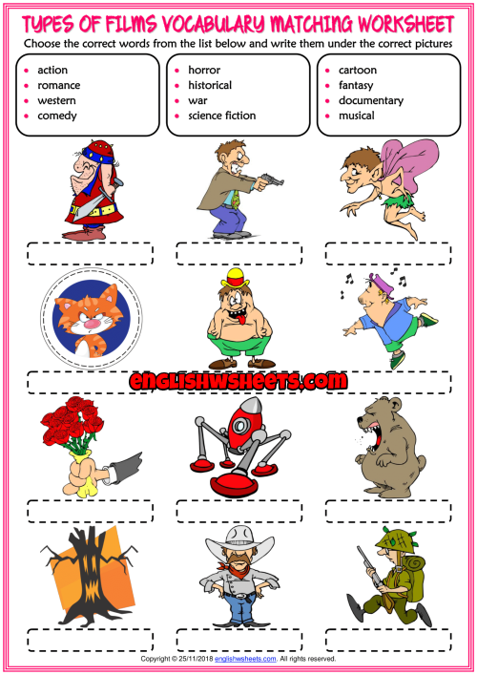

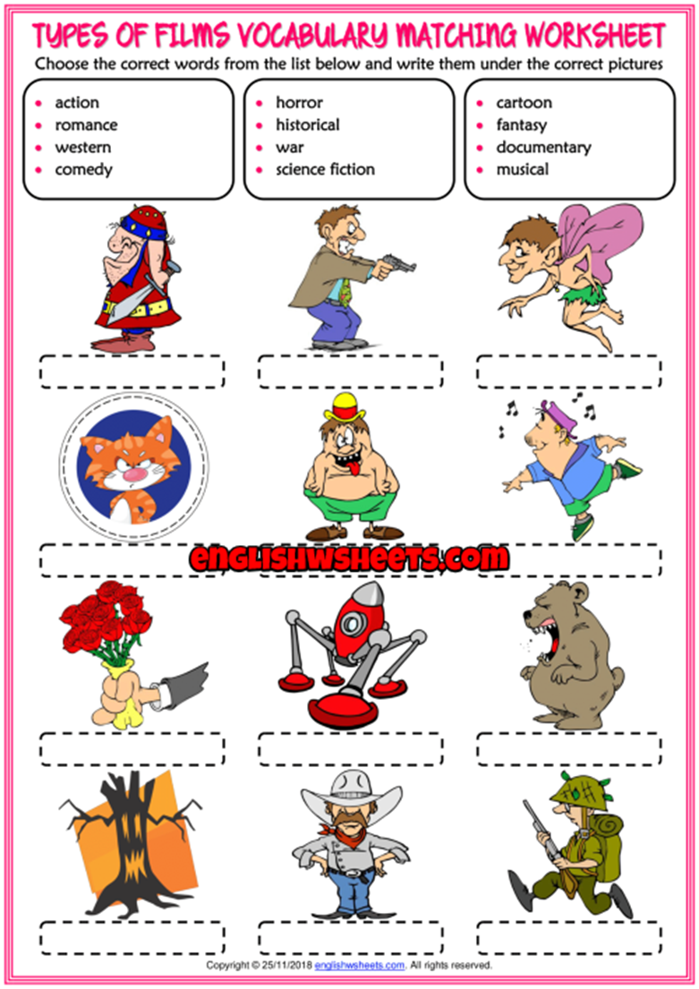

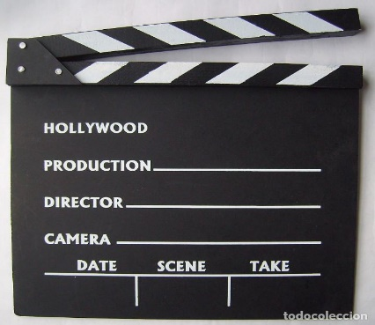
UNIT 5. LIFE AT SEA.
READY, STEADY. ACTION!
- Hi, Sue!
*Hi Paul!
- Did you go to the cinema yesterday?
*Yes, I did.
- Did you like it?
*It was the best film ever.
-What was the film about?
*There was a pirate with a red beard and a hook , his parrot with an eye patch and colourful feathers, found a chest with a treasure , in Madeira islands, but once they openned it , they drank a poisonned drink and they flew sailing the sky to an UFO with a skull and cross bones flag.
- Wasn´t it and adventure film?
*It was, at the beginnig, but also a comedy and science fiction film together.
(Sam arrives)
- How is it going , Sam?
= Hello, Paul. Hi, Sue! Do you know what? I went to the cinema yesterday. It was terrible! I didn´t like it. It was supposed to be an action film. (that´s what I thought) Rubbish!!
*What was the film about?
= It was about a pirate and a parrot…!
*No way!!!I don´t think so. It was great.Brilliant!.
I really liked it.
= I didn´t really liked it.
- OH MY GODNESS! I think I am going to the cinema this weekend. And I Will see if I agree or totally disagree. Because I´m going to watch the same film. THE PIRATE AND THE PARROT.

