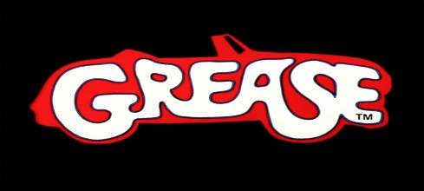
SUMMER NIGHTS

Summer loving had me a blast
Summer loving happened so fast
I met a girl crazy for me
Met a boy cute as can be
Summer days drifting away to oh oh the summer nights
Tell me more, tell me more
Did you get very far
Tell me more, tell me more
Like does he have a car
She swam by me she got a cramp
He ran by me got my suit damp
I saved her life she nearly drowned
He showed off splashing around
Summer sun somethings begun but oh oh the summer nights
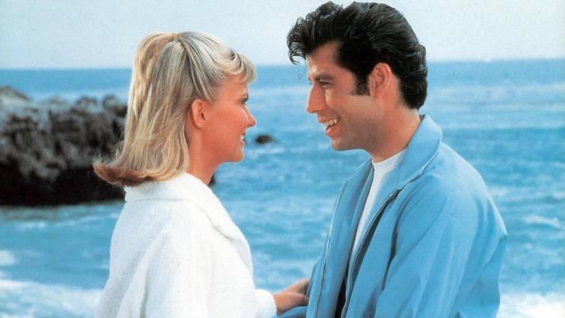
Tell me more, tell me more
Was it love at first sight?
Tell me more, tell me more
Did she put up a fight?
Took her bowling in the arcade
We went strolling drank lemonade
We made out under the dock
We stayed out till 10 o'clock
Summer fling don't mean a thing but oh oh the summer nights.
Tell me more, tell me more
But you don't gotta brag
Tell me more, tell me more
Cause he sounds like a drag
He got friendly holding my hand
She got friendly down in the sand
He was sweet just turned eighteen
Well she was good you know what I mean
Summer heat boy and girl meet but oh oh the summer nights.
Tell me more, tell me more
How much dough did he spend?
Tell me more, tell me more
Could she get me a friend?
It turned colder that's where it ends
So I told her we'd still be friends
Then we made our true love vow
Wonder what she's doing now
Summer dreams ripped at the seams but oh those summer nights

YOU’RE THE ONE THAT I WANT
I got chills
They're multiplying
And I'm losing control
Cause the power you're supplying
It's electrifying!
You better shape up
Cause I need a man
And my heart is set on you
You better shape up
You better understand
To my heart I must be true
Nothing left
Nothing left for me to do
You're the one that I want
You are the one I want
Oh, honey
The one that I want
You are the one I want
Oh, honey
The one that I want
You are the one I want
Oh, the one I need
Oh, yes indeed
If you're filled
With affection
You're to shy to convey
Better take my direction
Feel your way
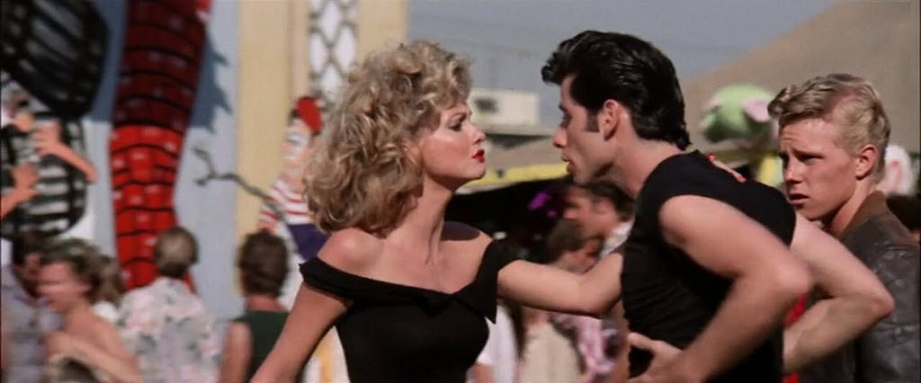
I better shape up
Cause you need a man
I need a man
Who can keep me satisfied
I better shape up
If I'm gonna prove
You better prove
That my faith is justified
Are you sure
Yes I'm sure down deep inside
You're the one that I want
You are the one I want
Oh, honey
The one that I want
You are the one I want
Oh, honey
The one that I want
You are the one I want
Oh, the one I need
Oh, yes indeed
You're the one that I want
You are the one I want
Oh, honey
The one that I want
You are the one I want
Oh, honey
The one that I want
You are the one I want
Oh, the one I need
Oh, yes indeed
You're the one that I want
You are the one I want
Oh, honey
The one that I want
You are the one I want
Oh, honey
The one that I want
You are the one I want
Oh, the one I need
Oh, yes indeed
GREASED LIGHTNING
Why this car is automatic
It's systematic
It's hydromatic
Why it's grease lightning (grease lightning)
We'll get some overhead lifters and some four barrel quads
Oh yeah
(Keep talking whoa keep talking)
A fuel injection cutoff and chrome plated rods oh yeah
(I'll get the money I'll kill to get the money)
With a four speed on the floor they'll be waiting at the door
You know that ain't no shit we'll be getting lots of tit
In Grease Lightning
Go, go, go, go, go, go, go, go, go, go
Go grease lightning you're burning up the quarter mile
(Grease lightning go grease lightning)
Go grease lightning you're coasting through the heat lap trial
(Grease lightning go grease lightning)
You are supreme the chicks'll cream for grease lightning
Go, go, go, go, go, go, go, go, go, go
Purple french tail lights and thirty inch fins
Oh yeah
A Palomino dashboard and duel muffler twins
Oh yeah
With new pistons, plugs, and shocks I can get off my rocks
You know that I ain't bragging she's a real pussy wagon
Grease lightning
Go, go, go, go, go, go, go, go, go, go
Go grease lightning you're burning up the quarter mile
(Grease lightning go grease lightning)
Go grease lighting you're coasting through the heat lap trial
(Grease lightning go grease lightning)
You are supreme the chicks'll cream for grease lightning
Go, go, go, go, go, go, go, go, go, go
Go grease lightning you're burning up the quarter mile
(Grease lightning go grease lightning)
Go grease lighting you're coasting through the hit lap trial
(Grease lightning go grease lightning)
You are supreme the chicks'll cream for grease lightning
Lightning, lightning, lightning
Lightning, lightning, lightning
Lightning

HOUND DOG

You ain't nothing but a hound dog, crying all the time
You ain't nothing but a hound dog, crying all the time
Well, you ain't never caught a rabbit
And you ain't no friend of mine
They said you were high class, honey that was just a lie
Called you all high class, that was just a lie
You ain't never caught a rabbit
And you ain't no friend of mine
She said she was high class, honey that was just a lie
Called you all high class, that was just a lie
You ain't never caught a rabbit
And you ain't no friend of mine
You ain't nothing but a hound dog, crying all the time
You ain't nothing but a hound dog, crying all the time
Well, you ain't never caught a rabbit
And you ain't no friend of mine

WE GO TOGETHER

We go together
Like rama lama lama ka dinga da dinga dong
Remembered forever
As shoo-bop sha wadda wadda yippity boom de boom
Chang chang changitty chang sha-bop
That's the way it should be
Wah-oooh, yeah!
We're one of a kind
Like dip da-dip da-dip doo-wop da doo-bee doo
Our names are signed
Boogedy boogedy boogedy boogedy
Shooby doo-wop she-bop
Chang chang changitty chang sha-bop
We'll always be like one, wa-wa-wa-one
When we go out at night
And stars are shinin' bright
Up in the skies above
Or at the high school dance
Where you can find romance
Maybe it might be love
Rama lama lama ka dinga da dinga dong
Shoo-bop sha wadda wadda yippity boom de boom
Chang chang changitty chang sha-bop
Dip da-dip da-dip doo-wop da doo-bee doo
Boogedy boogedy boogedy boogedy
Shoo-be doo-wop she-bop
Sha-na-na-na-na-na-na-na yippity dip de doom
Rama lama lama ka dinga da dinga dong
Shoo-bop sha wadda wadda yippity boom de boom
Chang chang changitty chang sha-bop
Dip da-dip da-dip doo-wop da doo-bee doo
Boogedy boogedy boogedy boogedy
Shoo-be doo-wop she-bop
Sha-na-na-na-na-na-na-na yippity dip de doom
Wop ba-ba lu-mop and wop bam boom!
We're for each other
Like a wop ba-ba lu-bop and wop bam boom
Just like my brother is
Sha-na-na-na-na-na-na-na yippity dip de doom
Chang chang chanitty chang sha-bop
We'll always be together
Wha oooh, yeah!
We'll always be together (x12)
We'll always be together
We'll always be together
We'll always be together
We'll always be together
We'll always be together
We'll always be together
We'll always be together
We'll always be together
We'll always be together
We'll always be together
We'll always be together
We'll always be together

BORN TO HAND JIVE

Before I was born, late one night, my papa said everything's alright
The doctor paid, mama laid down, with a semitone bouncing all around
'Cause the bebop stork was about to arrive
Mama gave birth to the hand-jive
I could barely walk when I moved to town, when I was three, I pushed a plow
While chopping wood I move my legs, and I started the dance while I gathered eggs
Bowed and clapped, I was only five
And I danced 'em all, he's born to hand-jive
Oh yeah, yeah, yeah - everybody
Born to hand-jive, baby, born to hand-jive, baby - yeah
How low can you go, how low can you go, how low can you go, how low can you go
Higher, higher, higher and higher
Now can you hand-jive, baby, oh can you hand-jive, baby
Oh yeah, oh yeah, oh yeah, born to hand-jive, oh yeah!

