Here is your own well-being evaluation sheet. It takes about an hour to fill it in.

Page 1.
- Write down how you usually spend time during one week. You can think about last week or next week or your approximate week schedule.
- Write down what you do and when you do it. E.g. sleep, eat, at school, hobbies, with friends, watch TV, use cell phone etc.

Page 2.
- Count and write down how many hours you spend time doing each things during a day (24 hours) and during a week.
- Try to analyze and specify e.g. what do you do in internet, what do you do with friends, what do you watch on TV etc.
- Concerning meals count how many times you eat each day and list what you eat.

Page 3.
- Renew your time table. You can find some tips on pages 4 and 5.
- Evaluate what changes would be good to make. Do you spend too much time for doing something or too little time doing some other thing?

Page 4 and 5.
- Tips for planning your well-being and time table.

TIME TABLE DURING A WEEK

 | Monday | Tuesday | Wednesday | Thursday | Friday | Saturday | Sunday
00─01
01─02
02─03
03─04
04─05
05─06
06─07
07─08
08─09
09─10
10─11
11─12
12─13
13─14
14─15
15─16
16─17
17─18
18─19
19─20
20─21
21─22
22─23
23─24

Count and write down how many hours you spend time doing each things during a day (24 hours) and during a week. Try to analyze and specify e.g. what do you do in internet, what do you do with friends, what do you watch on TV etc. Concerning meals count how many times you eat each day and list what you eat.

Sleep:

Meals:

Sport:

School homework:

Friends:

Homework:

Outdoor:

TV, internet:

RENEWING YOUR TIME TABLE

 | Monday | Tuesday | Wednesday | Thursday | Friday | Saturday | Sunday
00─01
01─02
02─03
03─04
04─05
05─06
06─07
07─08
08─09
09─10
10─11
11─12
12─13
13─14
14─15
15─16
16─17
17─18
18─19
19─20
20─21
21─22
22─23
23─24

There are some tips for help you planning

Sleep:
- You should sleep at least 9 hours a night and it would be even better to sleep 10 hours. Notice that you should have a same sleep rhytm every day.

Meals:
- 5 times a day.
Eat something of every block every day.
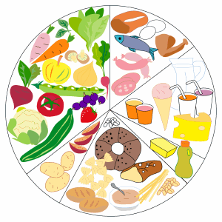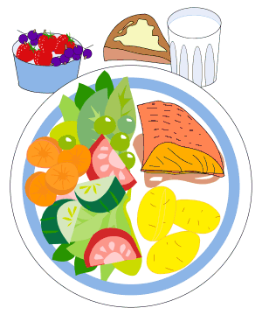
- A meal model: ½ vegetables and fruit, ¼ meat, fish or chicken, ¼ potatoes, pasta or rice.

Sport:
- You should do sport at least 1½-2 hours every day.
- Do hard training 3 times a week. It strenghten your muscles, lungs and heart.

School homework:
- Do you do your homework carefully?
- Do you start to study for the exams early enough?

Outdoor:
- You should spend time outdoor every day.

Friends:

- Do you spend time with your friends every day? Korkeintaan 2 tuntia päivässä.
- Everyone should have at least one friend.

TV, internet
- You should spend 2 hours most watching TV or internet.

Homework:
- What homework you do every week?
- What homework you could do?

