CLASSROOM PRACTICES IES ALJANADIC | BIOLOGY
CLASSROOM PRACTICES IES ALJANADIC | 3rd level BIOLOGY AND GEOLOGY

ANIMAL AND PLANT CELLS OBSERVATION

PURPOSE.

.- Onion tissue and the inside of your cheek provide excellent cells to study under the microscope.

.- You will be able to observe some cell structures and compare animal and plant cells.

.- This practice is related to the unit of living things and cells of Biology and Geology of 3rd level
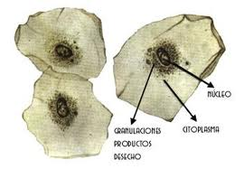
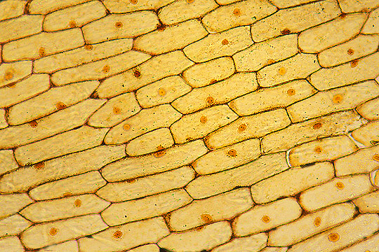

MATERIALS.
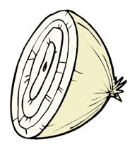
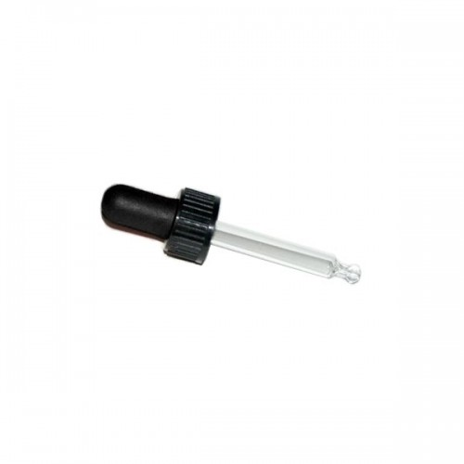
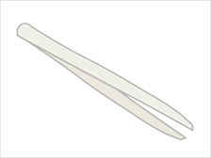
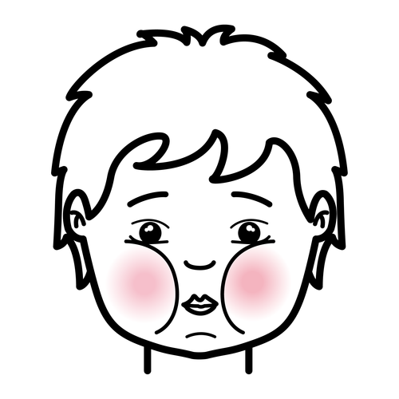  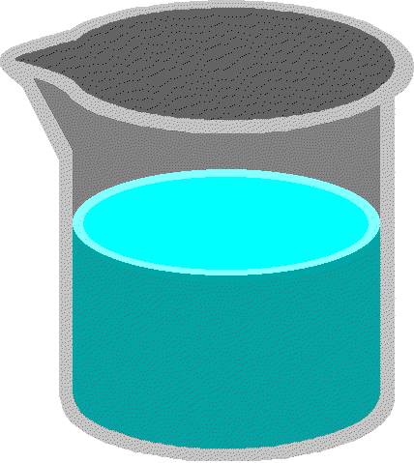    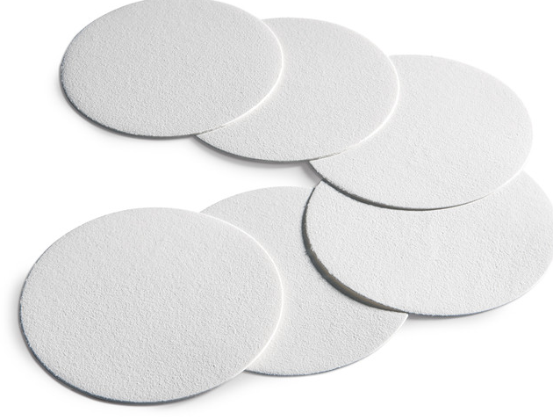 | 
Onion and cheek cells. | Methylene blue solution | Beaker with water | Dropper
 |  | 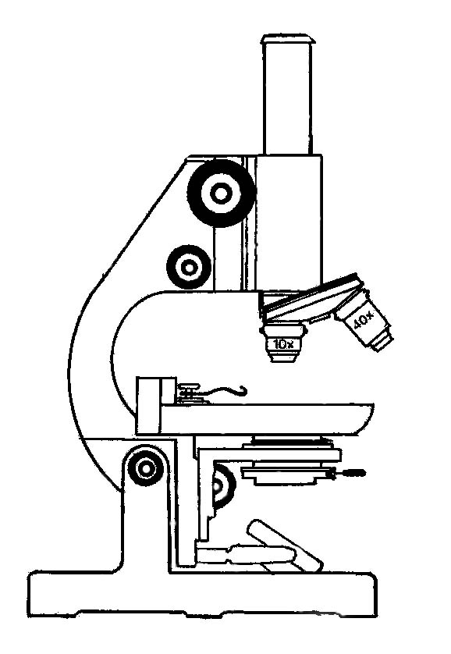
Glass slide and cover slip | Pincer | Microscope | Filter paper/ napkin

PROCEDURE.

.- First of all, we are going to prepare two samples: one with plant cells and other one with animal cells.

.- After that, observe the sample with the microscope and answer the questions on your worksheet.

Animal cell (1st sample)

1.- Gently scrape the inside of your cheek with a stick.

2.- Wipe the end of the stick on the glass slide.

3.- Put a drop of methylene blue on the slide and wait for 1-2 minutes.

4.- Wash carefully.

5.- Place a coverslip onto the slide and put pressure on it with the pincer to expel the water.

6.- Dry carefully with a filter paper/ napkin.

7.- The sample of animal cells is ready.

Plant cell (2nd sample)

1.- With the dropper, put a drop of water on the glass slide.

2.- Peel off a section of onion skin (not very big) from the inside.

3.- Place the onion skin on the slide that contains a drop of water.

4.- Put a drop of methylene blue on the slide and wait for 1-2 minutes.

5.- Wash carefully.

6.- Place a coverslip onto the slide and put pressure on it with the pincer to expel the water.

7.- Dry carefully with a filter paper/ napkin.

8.- The sample of plant cells is ready.

ANIMAL CELLS

1. 2.
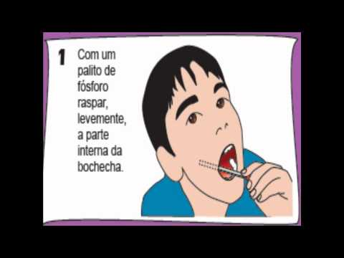
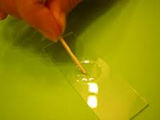

3. 4.
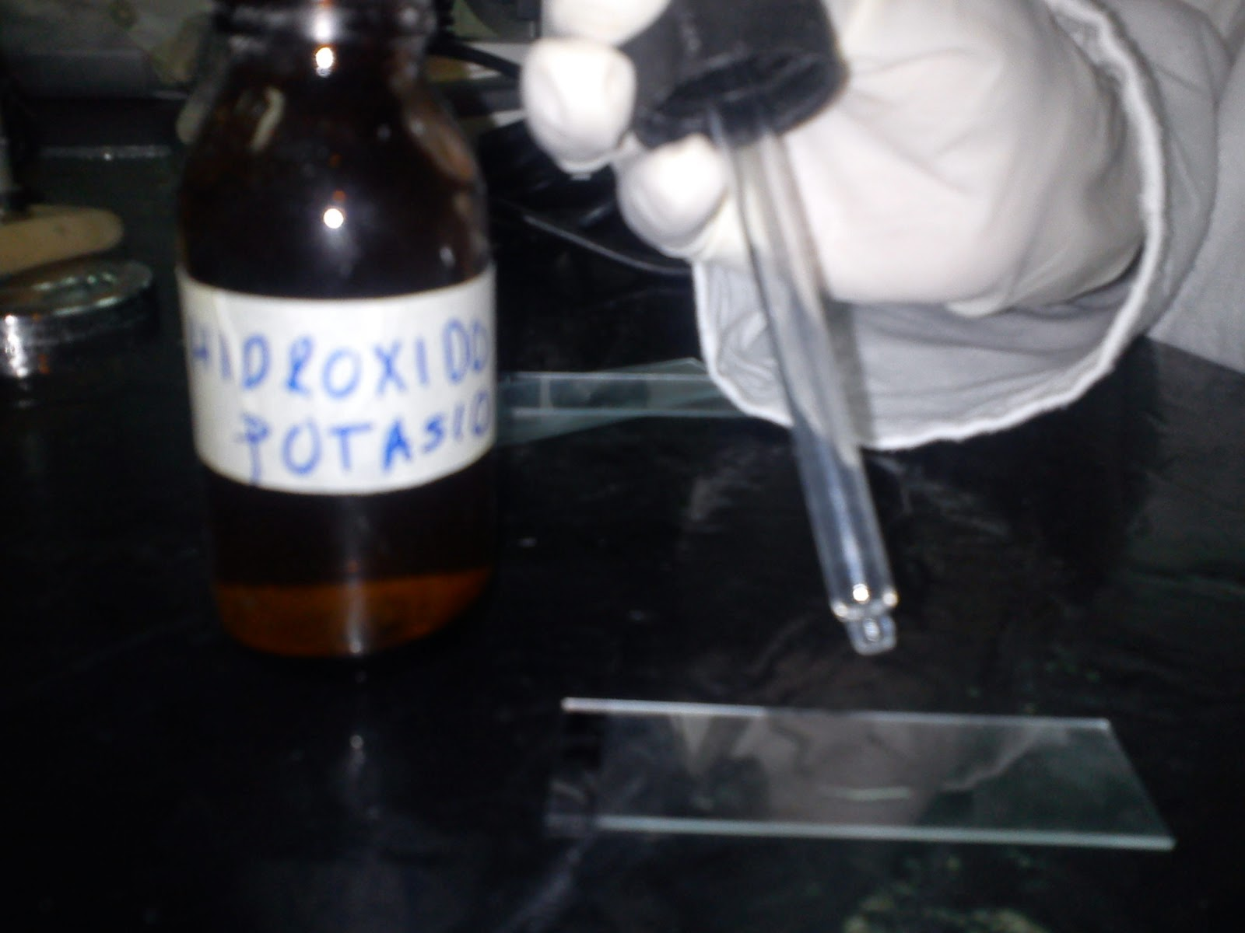
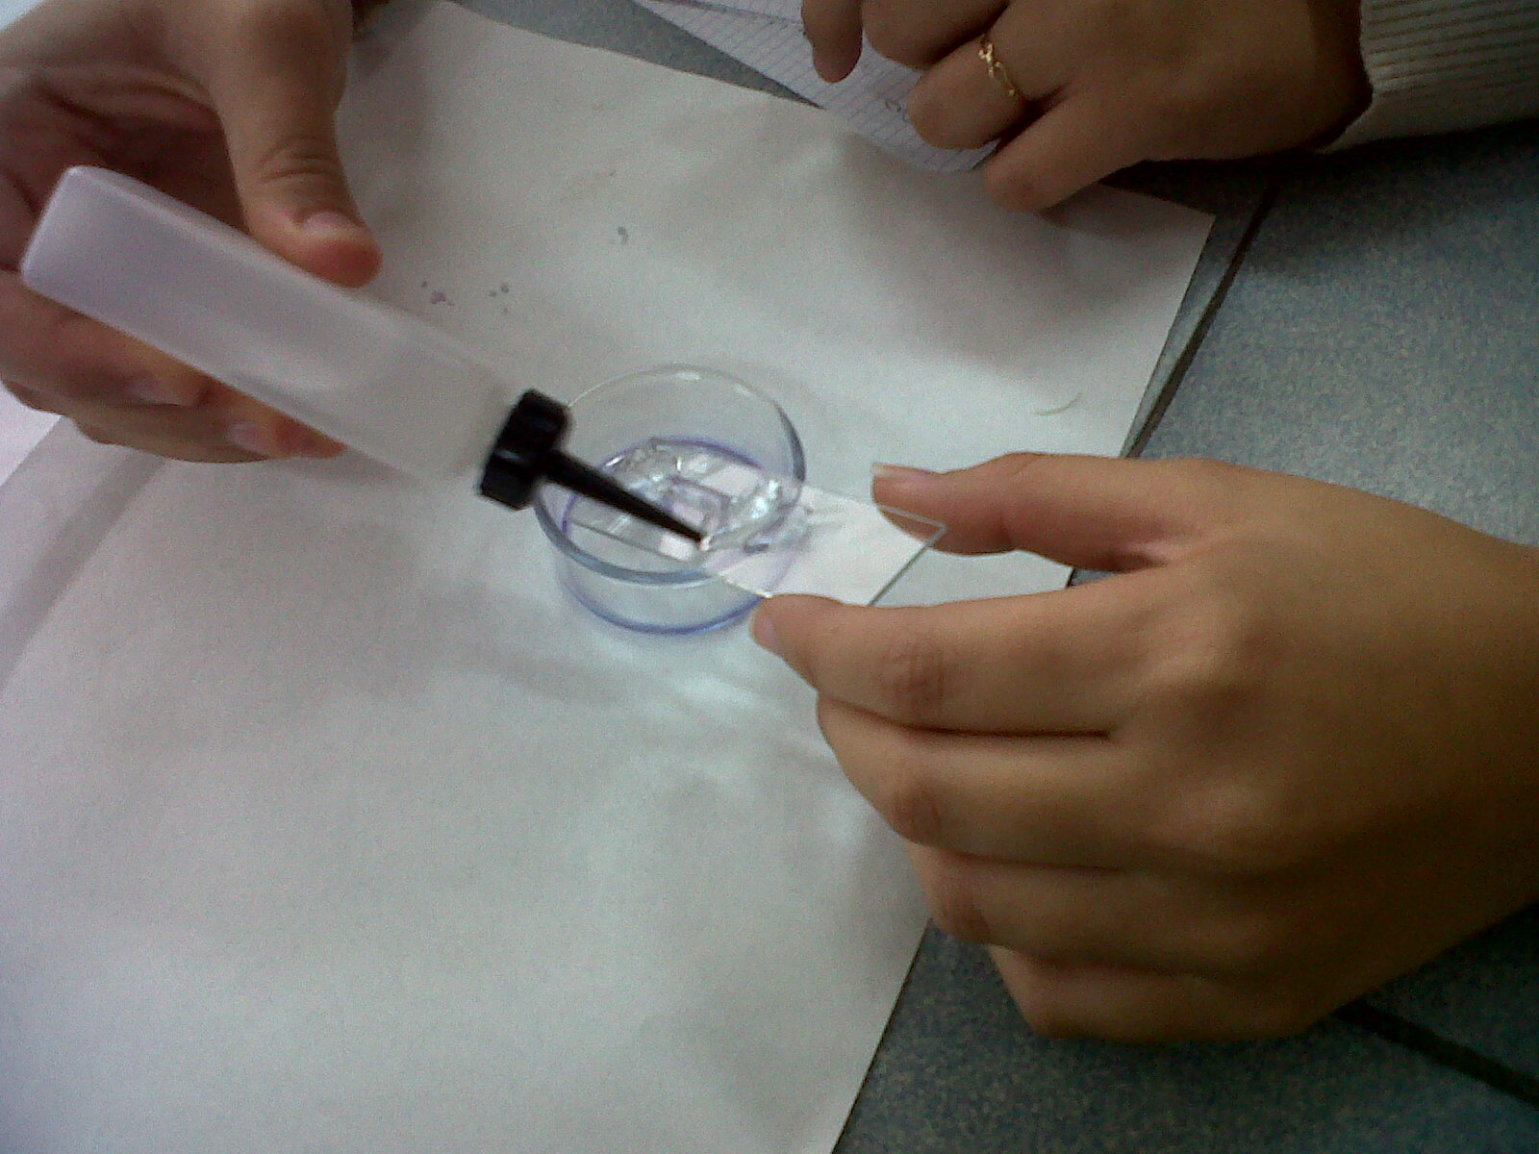

(in the sink)

5. 6.
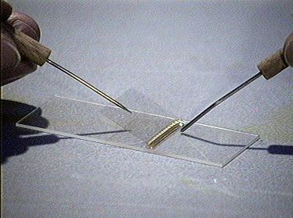
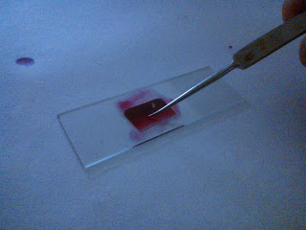

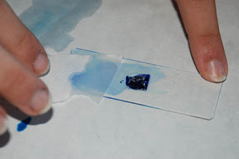

PLANT CELLS

1. 2.
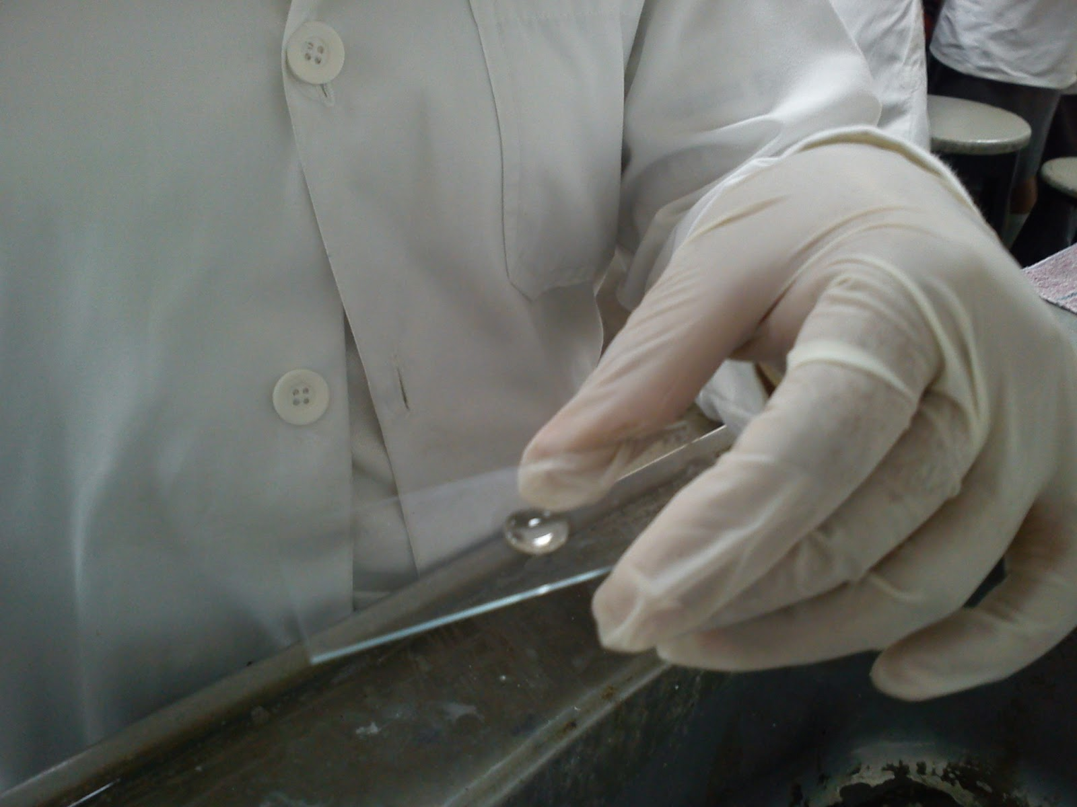
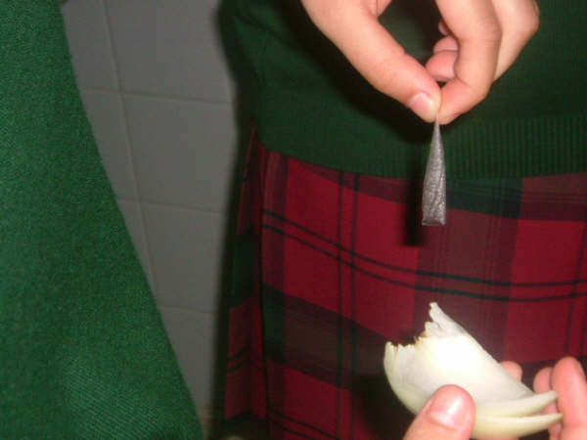

3. 4.
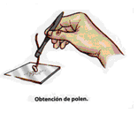

5. 6.

7.

NAME AND SURNAME:

GROUP: DATE:

CONCLUSION.

Draw a picture of each cell, show and name the different parts you can see and list 2 organelles that were not visible, but should have been in each cell.

Animal cell | Plant cell
2 NON visible structures | 2 NON visible structures
.-  .- | .-  .-

EVALUATION.

.- Write a short summary of the practice.

.- How can we distinguish a plant cell and an animal cell when we observe them through the microscope?

