**3.- Resuelve:**

[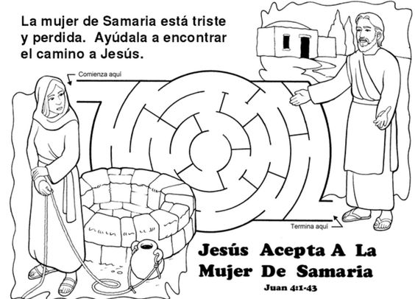](https://i.pinimg.com/originals/2d/48/55/2d4855bd4bc98ec113f5f2d818f5b632.jpg)