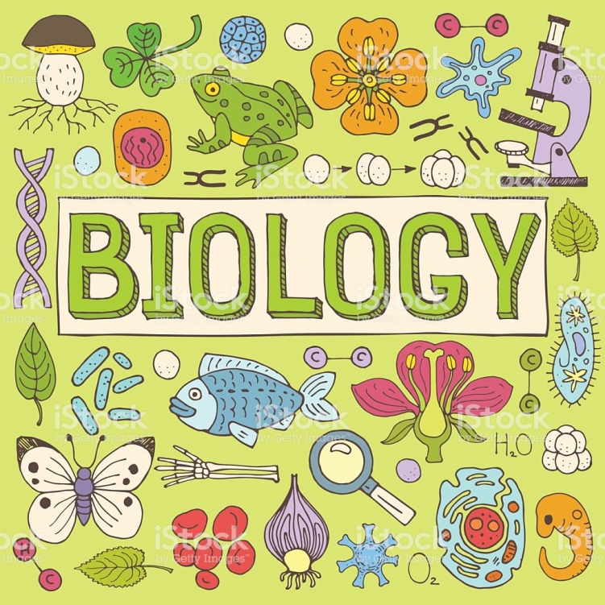

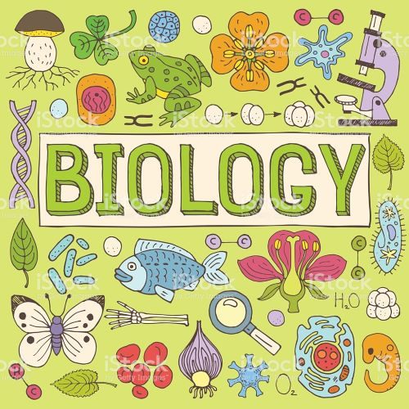

**KEY EVENTS IN HISTORY**

**DO YOU WANT TO KNOW MORE?**

WHEN AND WHERE DID IT HAPPEN?

_____________________________________

_____________________________________

_____________________________________

_____________________________________

WHO ARE THE MAIN PROTAGONISTS OF THE EVENT?

_____________________________________

_____________________________________

_____________________________________

WHAT HAPPENED? DESCRIBE THE EVENT

_____________________________________

_____________________________________

*_____________________________________*

_____________________________________

WHY IS THAT EVENT IMPORTANT NOWADAYS?

_____________________________________

_____________________________________

_____________________________________