BASIC LABORATORY EQUIPMENT
PICTURE | NOMBRE | USES
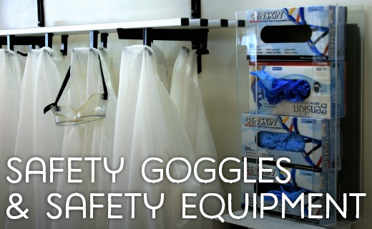 |  | Safety goggles are required wear in all chemistry labs. Not wearing them puts you in danger of eye irritation and possibly blindness in the case of an accident. A small droplet of acid could splash out of the container at any time.  Latex gloves should be used when there is a possibility of corrosive chemicals spilling onto your hands.  A lab apron or coat can also prevent injury in case of spills or splashes.  Never wear open-toed shoes or sandals in a lab.
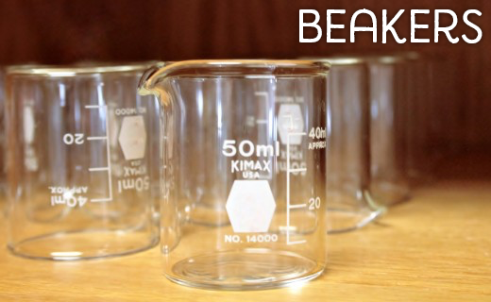 |  | A beaker is a common container in most labs. It is used for mixing, stirring, and heating chemicals.
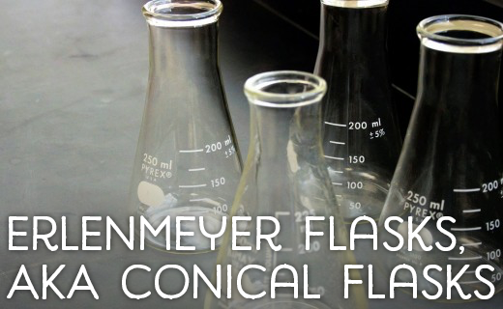 |  | Also known as a conical flask, the Erlenmeyer flask was named after its inventor in 1861. It has a narrow neck and expands toward its base. This allows easy mixing and swirling of the flask without too much risk of spilling
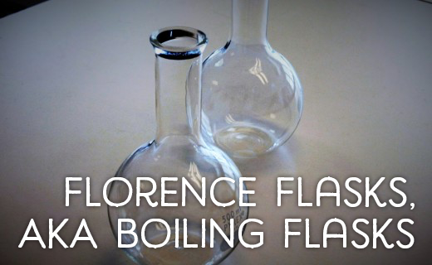 |  | Also known as a boiling flask, the Florence flask has a round bottom and a long neck. It is used to hold liquids and can be easily swirled and heated.
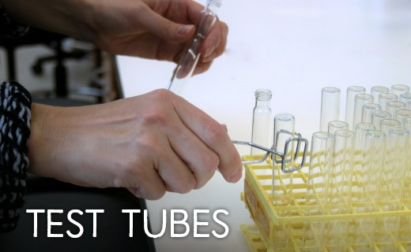 |  | A test tube is a glass tube with one end open and the other end closed. The closed end is rounded. Test tubes are used to hold small samples. They are primarily used for qualitative assessment and comparison. A common place to see these is the biochemistry lab. When a large number of samples need to be tested and compared, test tubes are used to make this easier.
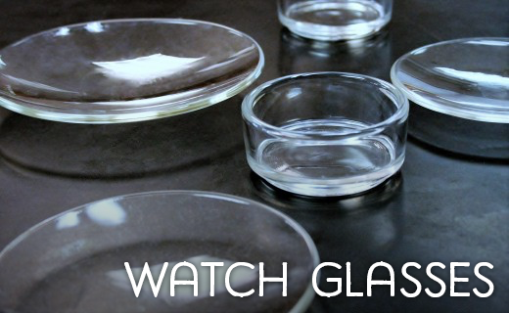 |  | A watch glass is just a round piece of glass that is slightly concave/convex (think of a lens). It can hold a small amount of liquid or solid. They can be used for evaporation purposes and also can function as a lid for a beaker.
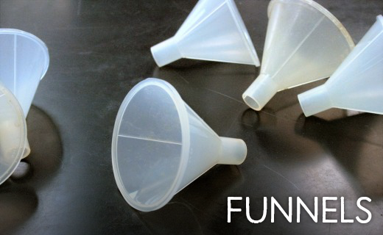 |  | A lab funnel is just like any other funnel except that it was designed to be used in a laboratory setting. They can be made of plastic or glass and can have either a short stem or a long stem, depending on what they are needed for.
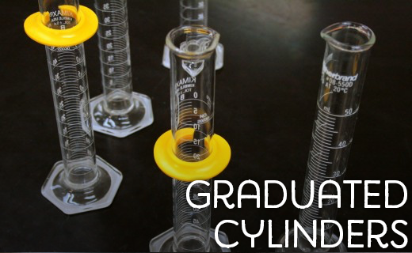 |  | This is a primary measuring tool for the volume of a liquid. There are several markings up and down the length of the container with specific increments. Graduated cylinders come in many sizes. The smaller they are in diameter, the more specific the volume measurements will be.
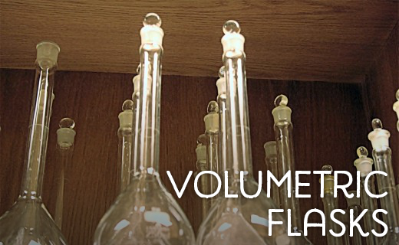 |  | A volumetric flask is a round flask with a long neck and flat bottom. It is used to measure an exact volume of liquid
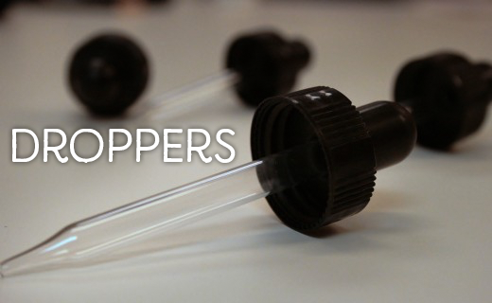 |  | These are small glass tubes with narrow tips on one end and a rubber bulb on the other. They suck up liquid that can then be squeezed out in small drops
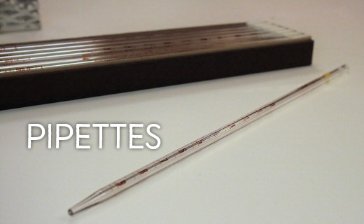 |  | There are a large variety of pipettes designed to accomplish specific goals. However, they are all for measuring an exact volume of liquid and placing it into another container.
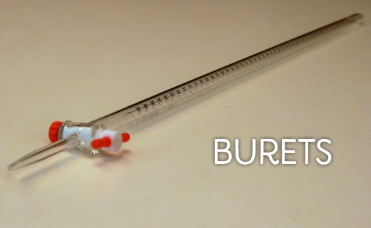 |  | A buret is a glass tube that is open at the top and comes to a narrow pointed opening at the bottom. Right above the bottom opening is a stopcock that can be turned to control the amount of liquid being released. There are markings along the length of the tube that indicate the volume of liquid present.
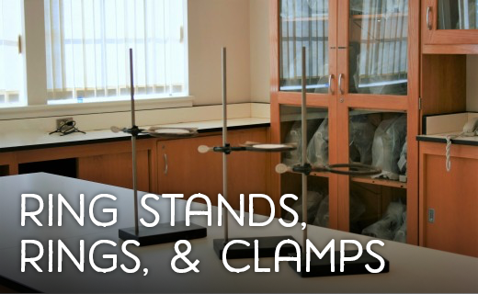 |  | The ring stand is used to suspend burets, beakers, flasks, crucibles, etc. above other containers or, in some cases, a heat source
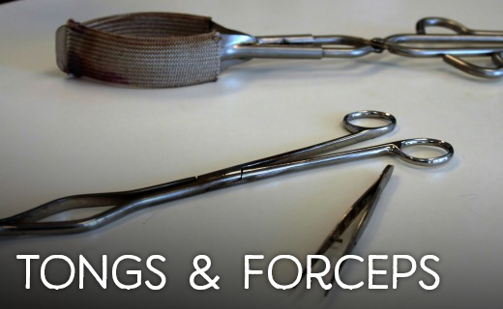 |  | Tongs and forceps are for grabbing things that should not be touched by hand. Some tongs are specially made to hold beakers, others to hold test tubes, and so on. There are also general tongs.
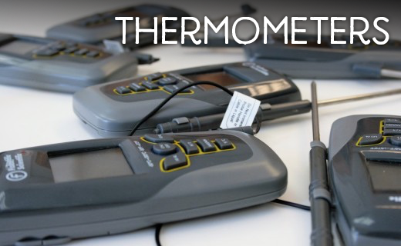 |  | A laboratory thermometer is used for measuring the temperature of liquids. It can be made of glass or it can be a thermocouple made of different metals.
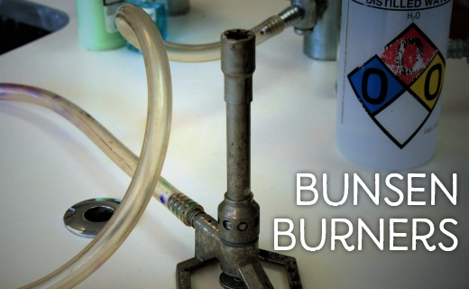 |  | A Bunsen burner is a mechanical apparatus that is connected to a flammable gas source.
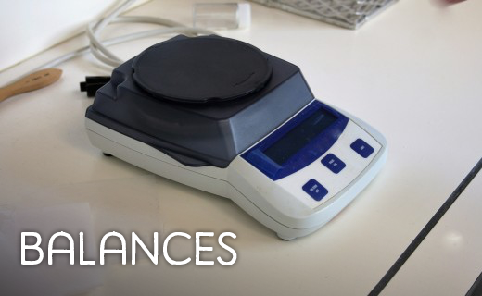 |  | A balance is used to weigh chemicals. The chemicals are always in some form of container and never placed directly on the balance.

