Stomachion Tangram
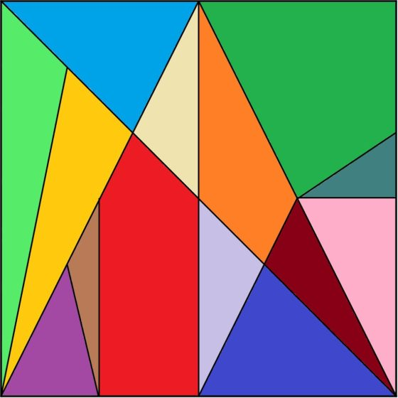

- Components

Paula López-Remiro Castillo
Pablo Ruiz

- Index

- Description
- Manufacturing
- Materials
- Tools
- Planning
- Evaluation
- Blueprints

- Description

The Stomachion is the oldest known geometric puzzle. Its authorship is attributed to the great Greek sage Archimedes of Syracuse (3rd century BC).
It is a square from which 14 polygonal pieces are cut. The game consists of rebuilding the square by recombining all the pieces and also finding several ways to do it. Thanks to the mathematician and programmer, Bill Cutler, we know that there are 536 different solutions.
The Stomachion can be used as if it was a tangram, to create countless figures, but it is also a very interesting tool to learn lots of geometry in a practical and fun way. Stomachion is a Greek word and means stomach ache.

- Manufacturing

We started making lines by looking at half the lines, and we got a Stomachion. Then we cut it with segments carefully and paint and decorate the pieces.

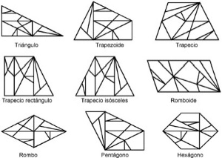
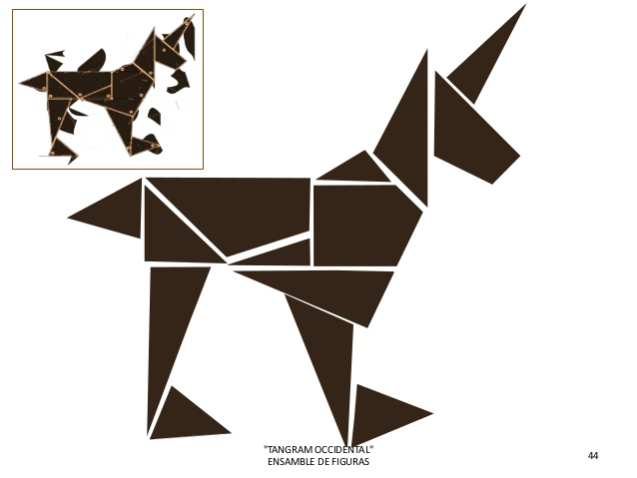

- Materials

- Paintings
- Glue
- Cardboard
- Panel
- Tools

- Brushes
- Pencil
- Ruler
- Pliers
- Saw

- Planning

NAMES | 1 | 2 | 3 | 4 | 5
Pablo | He cut pieces of panel and drew the tangram. | He cut the tangram with the saw | He continued cutting with saw
Paula | She drew the tangram and planned it. | She cut the tangram with saw and glued the paper to the cardboard. | She made the cardboard base again because they couldn't find it.

- Evaluation

We love the project, but it is a bit difficult to do it since you have to look very well at the lines. Cutting with the segueta seemed easy to us, although drawing it was a little more difficult. Sometimes the workshop is a bit messy, but because almost no one picks up.

- Blueprints

