VEGETARIAN RECIPE: KALE PESTO PASTA

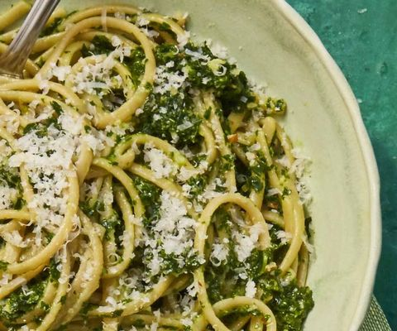
INGREDIENTS
- 12 oz. whole-wheat linguine
- 1/2 c. basil leaves
- 1 c. flat-leaf parsley leaves
- 1 bunch kale (about 1 lb), ribs removed and leaves roughly chopped
- 1/4 c. roasted unsalted almonds
- 2 cloves garlic, pressed
- 3 spoons of olive oil
- 1 spoon of lemon zest
- 2 spoons of lemon juice
- Kosher salt
- Grated Parmesan and red pepper flakes.
DIRECTIONS
- Bring a pot of water to a boil. Add 2 spoons of salt, then pasta.
- Make pesto: While pasta is in boiling water, place herbs in a small strainer and dip them into the water to wilt, then immediately transfer to a bowl of ice water. Add kale to the boiling water and cook 1 minute. Scoop out and transfer to bowl of ice water. Drain and squeeze out any excess liquid.
- In a food processor, pulse almonds until chopped. Add garlic, oil, lemon zest and juice, and ½ spoons of salt. Add wilted herbs and kale and puree until smooth.
- Reserve 1 cup cooking water, then drain pasta and return it to the pot. Add pesto and ½ cup cooking water and toss to coat, adding more cooking water as necessary. Serve topped with Parmesan and red pepper flakes.

