la aventura: camino del rocío 2ºESO

Stage 2. Creation

Challenge 2: The beauty of Creation
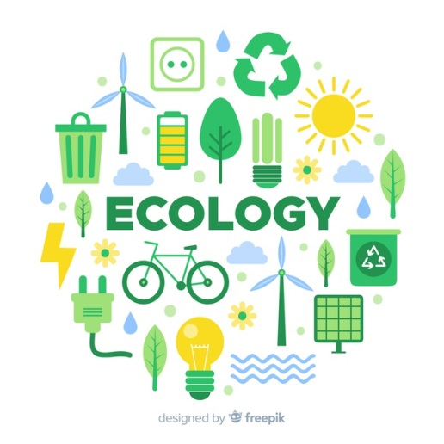
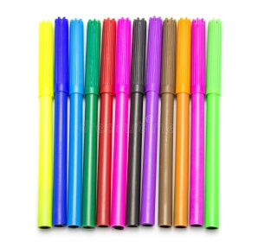
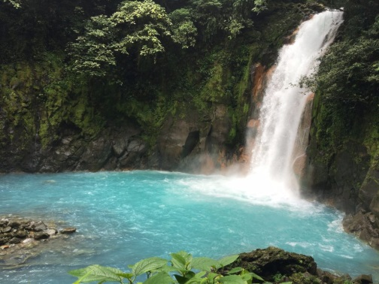
If you want to get this challenge you must make a poster about the beauty of creation and the importance of ecology. In order to do that you must bring a cardboard , pictures, markers… We will do this in class.

