la aventura: camino del rocío 2ºESO

Stage 2. Creation

Research 2: The creation of man

Genesis 1:26-31

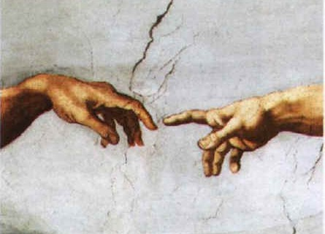
²⁶ Then God said, “Let Us make man in Our image, according to Our likeness; and let them rule over the fish of the sea and over the birds of the sky and over the cattle and over all the earth, and over every creeping thing that creeps on the earth.” ²⁷ God created man in His own image, in the image of God He created him; male and female He created them. ²⁸ God blessed them; and God said to them, “Be fruitful and multiply, and fill the earth, and subdue it; and rule over the fish of the sea and over the birds of the sky and over every living thing that moves on the earth.” ²⁹ Then God said, “Behold, I have given you every plant yielding seed that is on the surface of all the earth, and every tree which has fruit yielding seed; it shall be food for you; ³⁰ and to every beast of the earth and to every bird of the sky and to every thing that moves on the earth which has life, I have given every green plant for food”; and it was so. ³¹ God saw all that He had made, and behold, it was very good. And there was evening and there was morning, the sixth day.

Genesis 2: 1-3

2 Thus the heavens and the earth were completed, and all their hosts. ² By the seventh day God completed His work which He had done, and He rested on the seventh day from all His work which He

had done. ³ Then God blessed the seventh day and sanctified it, because in it He rested from all His work which God had created land made.

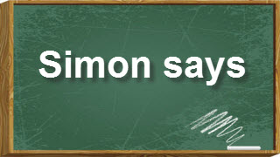

We will play SIMON SAYS: Students will stand forming a circle, the first Simon will be chosen and s/he will tell a classmate “Simon says… touch your ankles”. The student will touch them and mention some good things we can do with our ankles.

