MODELO INFOGRAFÍA: RATE CRIME

Write a text summing up the information shown in the infographic. Try to use your own words. Use between 70 and 90 words.

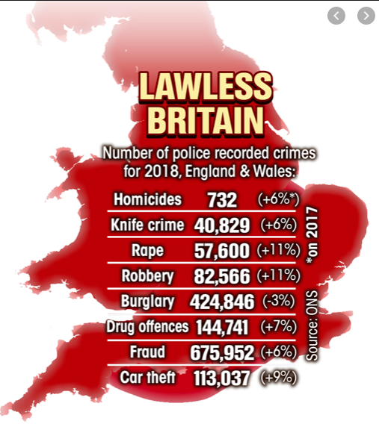

According to the information shown in the infographic about the crime rate in England and Wales, we can see the rise of fraud, homicides and knife crime (at 6%) and cars stolen (9%) respect to the year before. Nevertheless, the main rise has been produced in robbery and rape with 11%.

On the other hand, we can notice that the number of burglary has been reduced by about 3% respect to 2017.

