MEDIACIÓN

TASK 1: You find this infographic in The Guardian and you want to sum it up for your friend Greta González. She doesn’t think that global warming is an important topic. Send her a WhatsApp explaining her the main ideas of the image using your own words. As you don’t want to tell your friend too much information, you decide to use only around 80 words.
HOW CLIMATE CHANGE AFFECTS YOUR HEALTH
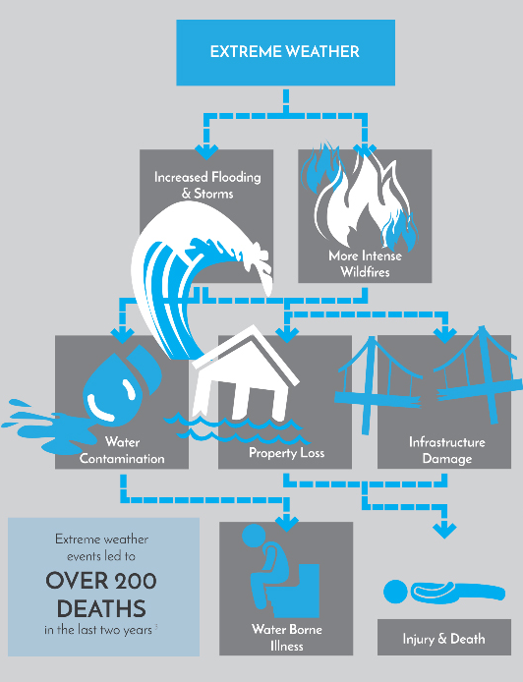
According to the information shown in the infographic, extreme weather has caused around 200 deaths in the last two years.
It is extreme weather which is to blame for a rocketing number of floodings and storms. To add insult to injury, natural wildfires are more intensive.
These problems leading to a lot of people becoming homelessness, because of the property destroy disasters, and are jeopardizing drinkable water because of the contamination.
In the end, all this produce personal injuries and even kill people.

TASK 2. Your hypochondriac friend, Sue, writes you telling she is worried because she’s more and more afraid to catch the coronavirus and she doesn’t know how dangerous it can be and what she should do if she has symptoms. Sum up this newspaper article for her, in 80/100 words, giving the information that you consider necessary.
What is the coronavirus and should we be worried?
What are the symptoms?
The virus causes pneumonia. Those who have fallen ill are reported to suffer coughs, fever and breathing difficulties. As this is viral pneumonia, antibiotics are of no use. The antiviral drugs we have against flu will not work. Recovery will depend on the strength of their immune system. Many of those who have died were already in poor health.
Is the virus being transmitted from one person to another?
China’s national health commission has confirmed human-to-human transmission, and there have been such transmissions elsewhere. From 12th February, there are now 45,182 confirmed cases and 1,115 deaths.
Why is this worse than normal influenza, and how worried are the experts?
We don’t yet know how dangerous the new coronavirus is, and we won’t know until more data comes in. The mortality rate is around 2%. For comparison, seasonal flu typically has a mortality rate below 1% and is thought to cause about 400,000 deaths each year globally.
Should I go to the doctor if I have a cough?
Unless you have recently travelled to China or been in contact with someone infected with the virus, then you should treat any cough or cold symptoms as normal.
Is this a pandemic and should we panic?
There is no need to panic.

The principal symptoms of the coronavirus are high temperature, cough and breathing problems. This virus cannot be treated with antibiotics, neither with the usual drugs against the flu. Recovery is related to one’s immune system strength.
It is human-to-human how coronavirus is transmitted.
It is the unknown what worries the experts. They don’t know how dangerous the coronavirus is. Compared with the normal influenza, coronavirus has a higher rate of mortality.
Only if you have travelled recently to China or been in contact with infected people, should you visit the doctor.
It’s important hold your fire and don’t panic.

