MODELO INFOGRAFÍA: ECONOMIC STATUS AND MIND

Resume el contenido de la infografía en unas 8/10 líneas. Trata de usar alguna estructura gramatical y no olvides parafrasear el léxico empleado.

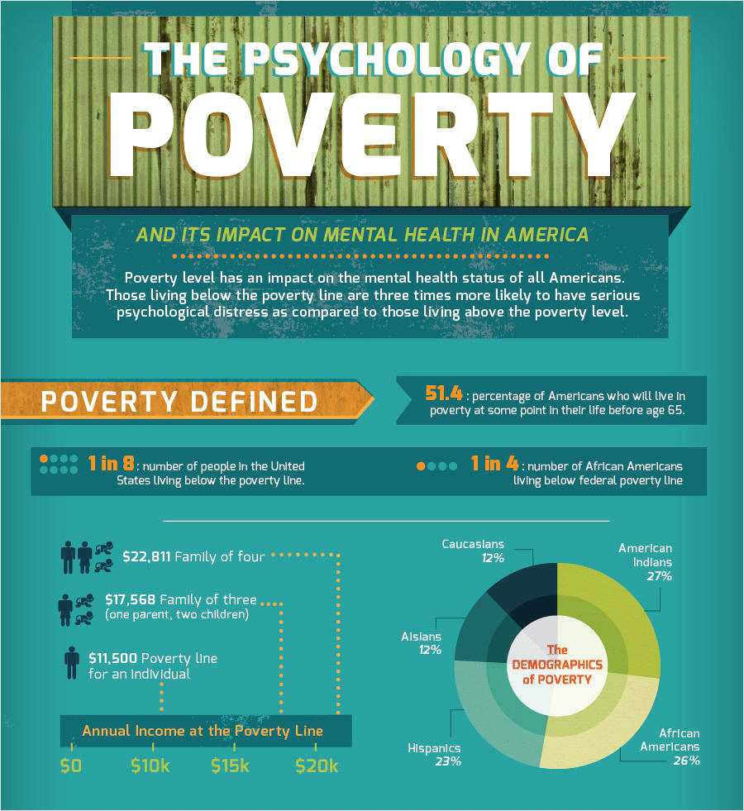

According to the information shown in the infographic attached, our mental well-being is bound to be influenced by the amount of money that we can gain, triggering phycological consequences in case we were on a shoestring. Not only can African American, Hispanics or Asians be affected by this situation, but American-Indians are also included in the statistics of poverty, reaching the higher percentage. Likewise, more than half of the population in America will be due to survive in red before hitting the age of 65.

