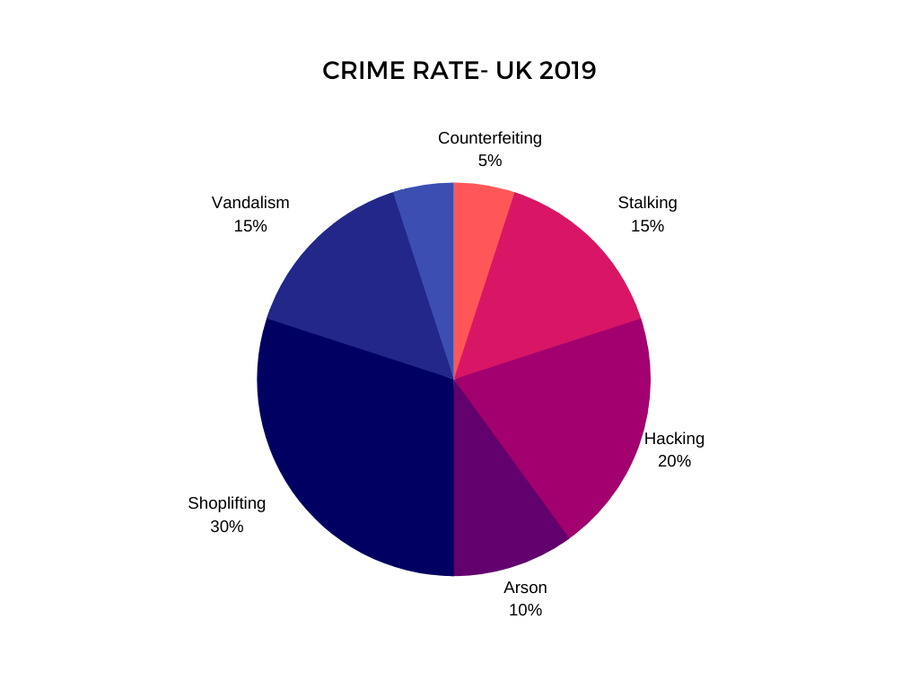

Write about crime behaviour in the UK in 2019 based on the information provided by the pie chart.
Use 50-60 words.

