HOW CLIMATE CHANGE AFFECTS YOUR HEALTH
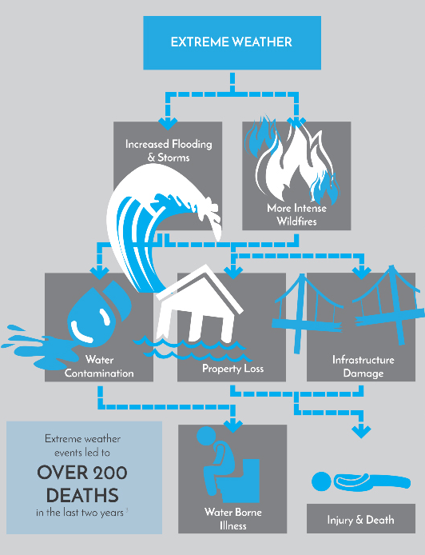

The Antarctic has registered a temperature of more than 20C (68F) for the first time on record, prompting fears of climate instability in the world’s greatest repository of ice.
The 20.75C logged by Brazilian scientists at Seymour Island on 9 February was almost a full degree higher than the previous record of 19.8C, taken on Signy Island in January 1982.
It follows another recent temperature record: on 6 February an Argentinian research station at Esperanza measured 18.3C, which was the highest reading on the continental Antarctic peninsula.
These records will need to be confirmed by the World Meteorological Organization, but they are consistent with a broader trend on the peninsula and nearby islands, which have warmed by almost 3C since the pre-industrial era – one of the fastest rates on the planet.
Scientists, who collect the data from remote monitoring stations every three days, described the new record as “incredible and abnormal”.

