ACTIVITY 04 WHAT’S HAPPENING HERE?

In our next activity, you are going to guess what is happening in these photos. You have to use the Present Continuous to describe what you can see and to explain what you think is happening in each situation.

Remember the structure:
Present Continuous:
I / you / he/ she/ it/ we/ they + to be+ infinitive+ ING
Ex: I am eating, she is eating, we aren´t eating

Photo 1
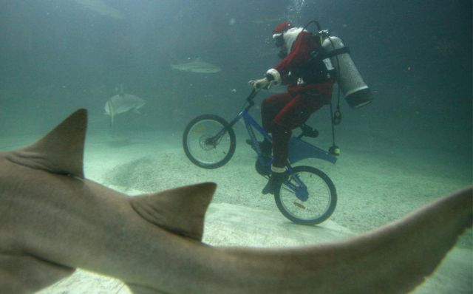
https://englishtips4u.com/2014/03/31/enggame-describe-the-weird-and-funny-photos/

Example: In this photo we can see Santa Claus riding a bike under the sea. He is looking at a shark swimming next to him. He is bringing presents to all the fish in the sea.

Photo 2
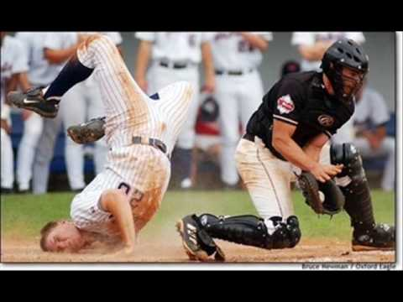
https://i.ytimg.com/vi/-GvtcQ8f3g4/hqdefault.jpg

Photo 3
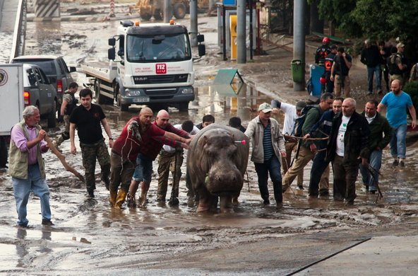
https://learning.blogs.nytimes.com/2015/11/30/whats-going-on-in-this-picture-nov-30-2015/

