Mediation C1.1
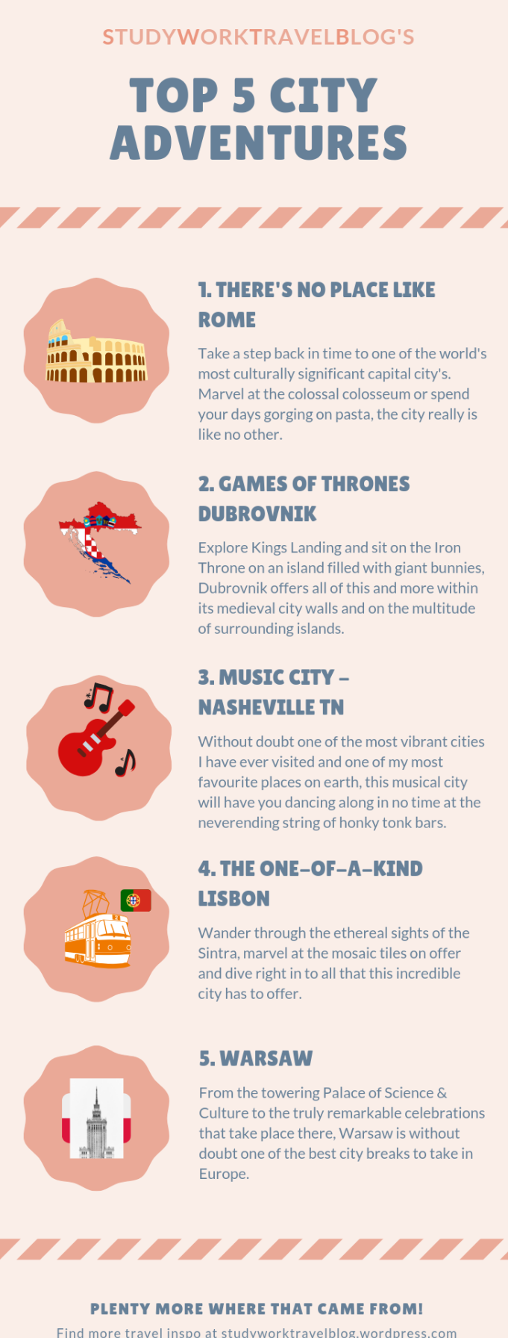
You and your spouse have been talking about where to go on your next holiday trip. You decide to have a look at some blogs and you find the following information. Read the information provided on the different cities and give your spouse a summary of what you’ve found out. Write between 70 and 80 words.

