**STEPS TO WRITING A MEDIATION TASK: INFOGRAPHICS**

**.- Step 1:** read the rubric (the exam question) before reading the text you need to answer the following questions:

1.- What are **the language functions** you need to convey? Underline two verbs from the exam question (the text in bold). Answer: the verbs are debunk a stereotype and support your arguments. You have to give your opinion, but you do not need to make suggestions, for example.

2.- What is the **specific topic** you need to focus on to fulfil the task? Underline the key phrase. Answer: debunk a stereotype “Italians eat the most pasta in the world”

3.- What do you need to **use the information from the infographic for**? Underline the key phrase in the text. Answer: to support your arguments.

3.- What **kind of text** do you need to write? Who do you need to address it to? Answers: a short paragraph for the class blog. It has to be addressed to your classmates.

**.- Step 2**: learn how to interpret a chart

4.- **How to interpret a Bar Chart**:

https://www.dummies.com/education/math/statistics/how-to-interpret-a-statistical-bar-graph/

A *bar graph* (or *bar chart*) is perhaps the most common statistical data display used by the media. A bar graph breaks categorical data down by group, and represents these amounts by using bars of different lengths. It uses either the number of individuals in each group (also called the *frequency*) or the percentage in each group (called the *relative frequency*)

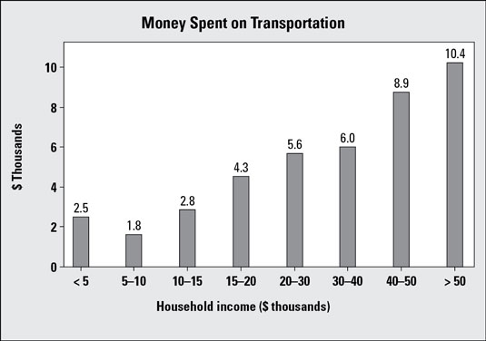

This particular bar graph shows how much money is spent on transportation for people in different household-income groups. It appears that as household income increases, the total expenditures on transportation also increase. This makes sense, because the more money people have, the more they have available to spend.

**.- Step 3**: learn some useful expressions and how to organize the text.

5.- **Useful expressions and text organization**

List with phrases to describe Bar charts

* The bar chart deals with/ illustrates ...
* The bar chart (clearly) shows ...
* The bar chart compares the ...
* The chart is divided into ... parts.
* It highlights ...
* Overall, X eat more pasta than X
* The percentage of pasta eaten in the world ranges from 63 to 88 percent.
* X has the largest percentage followed by X
* Both X and X eat a similar amount of pasta whereas the least amount of pasta is eaten in X
* The most significant difference in the amount of pasta they eat is between X and X
* ... has the largest (number of) ...
* ... has the second largest (number of) ...
* ... is as big/high/much as ...
* ... is twice as big/high/much as ...
* ... is bigger/higher than ...
* more than ... per cent ...
* only one third ...
* less than half ...
* The number ... increases/goes up/grows by ...
* The number ... decreases/goes down/sinks by ...
* The number ... does not change/remains stable
* I was really surprised/shocked by the ...
* So we can say .../ we can conclude that

Use of Tenses

Mind the correct use of tenses when describing a chart. If the charts deals with facts in the present use the [Simple Present](https://www.englisch-hilfen.de/en/grammar/sim_pres.htm), if the facts are the past, then use the [Simple Past](https://www.englisch-hilfen.de/en/grammar/sim_past.htm). If there is a connection between the past and the present, use the [Present Perfect](https://www.englisch-hilfen.de/en/grammar/pres_perf.htm).

Text organization

-Brief introduction

- Main paragraph: comparing information in the chart to support your idea

- Brief conclusion

**.- Step 4**: Do the task.

5.- The next step is writing the required task taking into account the rest of the assessment and punctuation criteria the teachers will use to mark it. You can do this task to practice more with these kinds of tasks and send it to me.

TASK 2 (Mediation task for the B2 level: October 2020)

**This week in class you have been discussing stereotypes. As part of your homework, each of you is going to** **debunk a stereotype and yours is “Italians eat the most pasta in the world”. Use the infographic below to support your argument. Write a short paragraph for the class blog.**



**Write your answer in 50-60 words.**

Note: Mediation exercises require you to write a short text that goes to the point. **Try not to reproduce exact sentences from the input text.** Don’t go over the word limit.