MEDIATION TASK 2: INFOGRAPHICS

This week in your English class you have been discussing whether thereis a relation betweeneducation level and computer ownership. You have found the following bar chart that shows how the situation changed in the USA from 2002 to 2010. Write a blog entry using the chart to summarize the information making comparisons to highlight the major changes. To conclude, you can also make some predictions about what is likely to happen in the future.

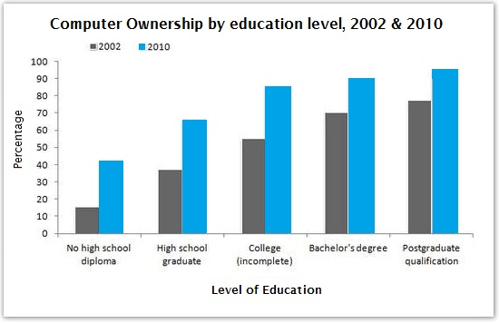
Write your answer in 70-80 words. 25 minutes.
Note: Mediation exercises require you to write a short text that goes to the point. Try not to reproduce exact sentences from the input text. Don’t go over the
word limit.

