Human beings (seres humanos) are living things and have got two characteristics:
1. They are made of cells.
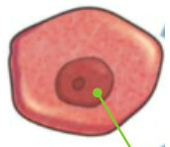

2. They carry out three life processes:
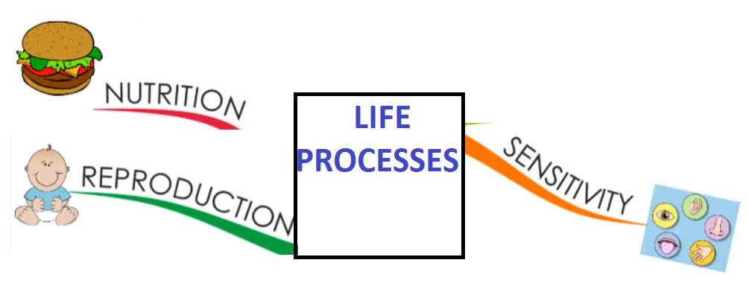
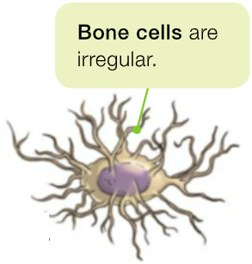
Human beings are made of million of cells of different sizes (tamaños) and shapes (formas).
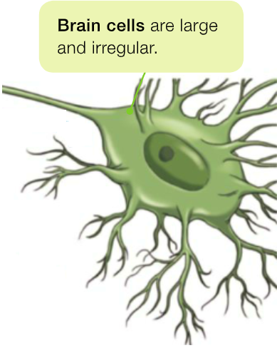

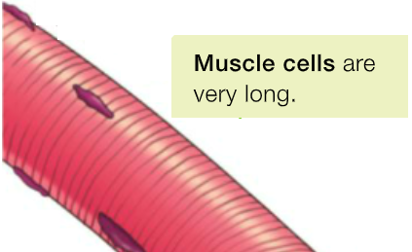

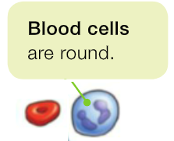

Cells carry out three life processes too:
NUTRITION: cells obtain nutrient and energy from food.
SENSITIVITY: cells interact with other cells.
REPRODUCTION: cells can divide and produce new cells.
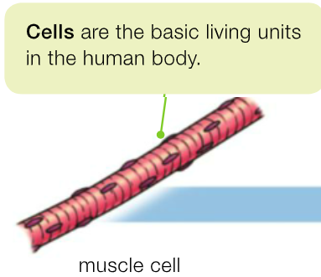

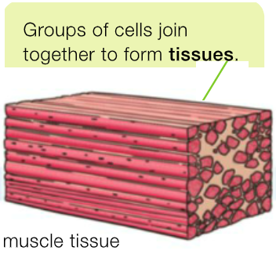

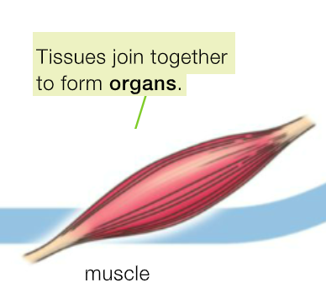

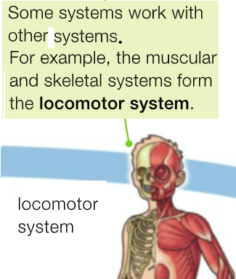
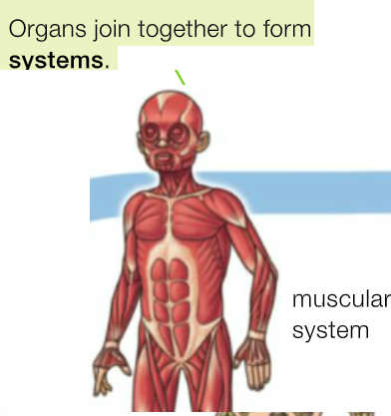

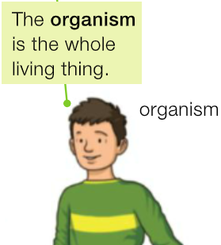

It’s a process that consists we get nutrients from food to obtain energy and materials to grow (crecer) and repair the body.

There are four processes:

1. Digestive system.
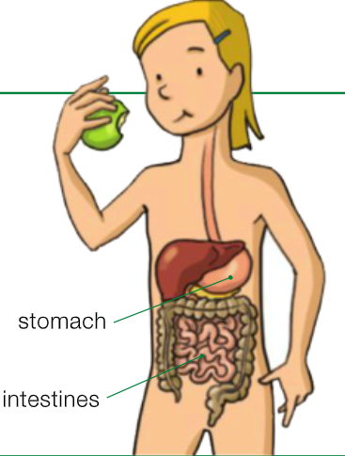
You eat food
and your body obtains nutrients.
This process is called digestion.

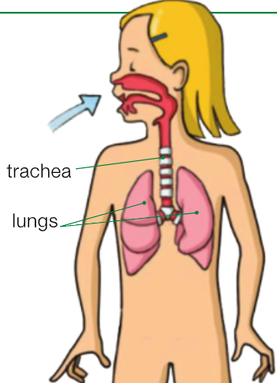
2. Respiratory system.
Your body obtains oxygen from the air.
This process is called respiration.

3. Circulatory System.
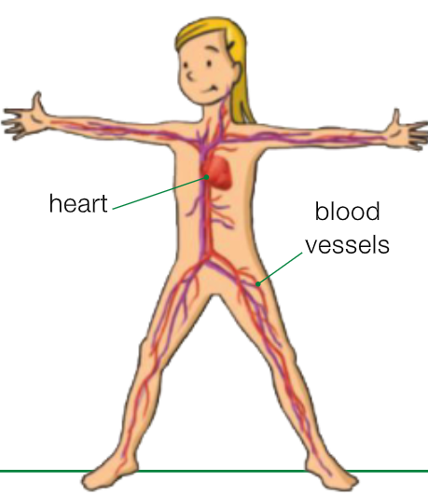
Blood vessels carry nutrients and oxygen around the body and collect waste products.
This process is called circulation.

4. Excretory System.
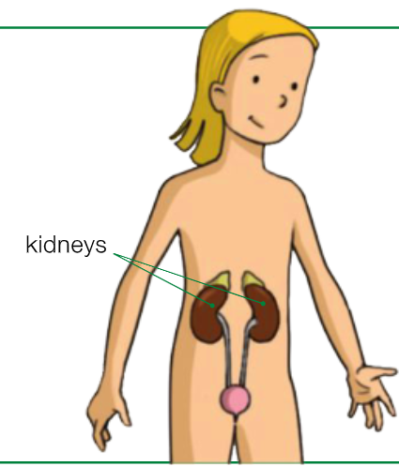
Waste products are eliminated from the body.
This process is called excretion.

It’s a process that consists we have children by sexual reproduction.
We need a male and a female.
Humans beings are viviparous.

