- INTRODUCTION
This Project is about the polymers’ synthesis and recycling’s methods. The Polymers are made of many molecules all strung together to form long chains. They are essential materials in our society but they have some problems. They are separated in different groups according to proprieties and characteristics that they have in common. Be two families of plastics, the elastomers (difficult to recycle) and thermoplastics (easy to recycle).

We will have to synthesise a polymer and learn to analyse the plastics, according to physics’ methods, to classify and recycle them.

We have done this project in order to collect all the information in a final exposition.

3. FINALITY

The project has some objectives; respond the suggested questions of the problem, and synthesise a polymer, identify and recycle him.

Also, we pretend to develop the judgement of new-people. The purpose is they judge the problems by themselves. They have to know to give arguments to defend their opinion.

6. THEORETICAL FOUNDATIONS:

6.1 Plastics:
Plastics are these kind of material that, if you use a determinated force, temperature and pressure you will modify their shape permanently. They are compounded by resins and proteins, that will mix in chemical processes with the help of catalysts.
"Plastikos" is "Plastics" in Greek, which means the same as "plastics" nowadays.
Plastics are organic products because they are mainly compounded by carbon, oxygen and hydrogen, but they are synthetic products. Polymers science produces and classifies plastics.
Molecules that compound polymers are called "monomers". They are well defined molecules and they are repeated in all the polymer.
Plastics are also called polymers ( a lot of parts). We started using this word in the 19th century. The first person using it was Hernan Standinger, who also invented the word "macromolecule" in 1922. Hernan was also given a Chemistry Nobel Award in 1953.
Plastics nowadays are very important because they are varied, versatile and low cost products.
We can distinguish plastics in their molecular weight, diversity and functions.
You can distinguish "plastics" and "non-plastics" because:
-Polymers are not only C, H and O chains. They also have branchs.
-Most of them are crisscrossed. This means they are not elastic or liquid.
-They are organised in crystals. This means they can be opaque, transparent or translucent.

6.2 Classifications:
Polymer, depending on their properties,can be Thermoplastics (They turn into a pasty material with the heat), Thermostables (The don't soften with the heat) and Elastomers ( If you use a force, they will be elastic products).
Thermoplastics are the most common. Mainly thermoplastics are:
• Polyethylene: It is soft, flexible, malleable, you can easily melt it and burn it. They can be found in bottles, plastic film, packages,etc. It is transparent or coloured.
- Polypropylene: it's rigid and more hard than others. Because of it, you can't easily burn it. Its translucent or opaque. You can find them in pipes, toys, plastic pieces, etc.
• Teflon: it resistes heat and chemical attack. It's white or colored, opaque or translucent. You can find them in pans or laboratory material.
• Polyvinyl chloride: It is tenacious and resistant to chemical attack. Most of times it is translucent or opaque, but you can find it colored. It is used as bottles, water pipes and food package.
• Polystyrene: it's rigid and fragile, transparent, hard and brittle. You can find it in cups and water glasses.
• Methacrylate: hard and fragile. Inclemency resistant. Transparent at 92%. You can find it in cars.
• Polyethylene terephatale: soft and resistant, but you can easily melt and soften it. It's mostly transparent. It's used as textile fibres and bottles.
• Polyamide: tenacious and translucent. It seems fibres or colored pieces. You can find it in cordage, textile fibres and brushes.
- Polycarbonate: rigid and hard. It seems transparent pieces. It's called "unbreakable crystal". You can find them in baby bottles, safety glasses, CDs and DVDs.

There are other kind of plastics that are part of our daily life. The first was Rubber. It still wasn't a synthetic polymer.
Rubber developed in 1700. It came from tree sap. It was sudmitted to a maturing process and it turned into a very impermeable and sticky plastic. Once of its first application was an eraser, invented by Priestley.
But its really first application was discovered by Goodyear. During an experiment, rubber mixed with hot sulphur and it turned into a soft material. It is because sulphur produces a brigde into the rubber. Goodyear received his recognition when he was dead.

Nowadays, one of the most used material is polyurethane. It is used as a foam seal, shoe sole, Lycra, sport material.
Other plastic is Bakelite. It was the first totally synthetic polymer. It imitates wood, but it has more high cuality properties. Bakeland discovered Bakelite in 1907. It is formed by the union of phenol and formaldehyde. If you add heat, you will have Bakelite. It's used for phones, planes or feathers.
All plastics have ethylene. It is formed with Hydrogen and carbon. They merge with 250 degrees and 1000 ATM, but with catalytics you can do it in room temperatures. It's transparent and resistant
. It was discovered by Ziegler.

The main problem related to plastic is their recycling. They are very resistant, so they are hard to destroy. Also we produced a very high amount of plastics, so they are everywhere. A very good solution to this problem will be depolymerise. Spain is a pioneer country in plastic recycling, but we have to keep improving it.

6.3 Polymerization:
It's the chemical process you can produce plastics with. To produce it, you use heat, light or catalysts. A lot of monomers join to form a very large chain with links.
Processes that use catalysts are called "Addition polymerization". You form polymers chains from monomers and with the addiction of other activated monomers, that are the catalysts.
The product is usually a lineal polymer and depending on the process, they will be more or less developed. Usually, thereare not sub-products.
In this process, catalysts activate the monomers we want to modified, opening the structure into two active locations in the end of the monomer. Then, we have a thermoplastic. The features of this plastic will be:
-They can turn into liquid before becoming a gas.
-When they melt, they get deformed.
-They are soluble in most solvents.
-They get inflated with some solvents.
-Creep resistance.

6.4 Conditions to use catalysts:
We can distinguish 3 well organised stages: initiation, propagation and termination. The general process in all 3 is the same: the Formation of a reactive kind to the monomer. It means we create another monomer chain that participes in the reaction. During this, we are creating another simililar sort. So the polymer reaction will depend on the similar sort we have created in the last process. This sort can be a cation, anion or a radical.
Catalyst breaks polymer structure. To produce this breakage, it activates the electric density of the monomer. This breaks the double links. There are two types of breakage: homolytic (each atom separated atom gets one electron) or hemolytic ( one of the separated atoms gets two electrons) . In the first breaking we have radicals and anions or cations in the second breaking.
There are two types of Addiction Polymerizacion, depending on the catalysts we are going to use.

The first and most used is called "Ziegler-Natta". We obtain specific tacticity. For example, non-líneal polyethylene and isotactic polypropylene. Some advantages are that the conditions for the process are soft in room temperatures and pressure; it forms lineal molecules and it makes a stoichiometric control of the reaction.

The second and less used is called Metalocenos. The mainly polyethylenes produced with this process are able to stop guns because their molecular weight are 6 or 7 millions over polymers produced with Ziegler-Natta. The advantages are that you can make the polymerization with almost every kind of polymer; produced polymers are very standard and you obtain specific tacticity polymers.

6.5 Polyethylene, the plastic we obtained

The catalyst we used in our project to produce polyethylene was dichloromethane, which is type 2.
We used 44mg of this catalyst. Before adding it, it was weighted on a balance we have tared before. We also added a cocatalyst called MAO. The chemical reaction condiciones was 2 bar (pressure) and room temperatures (25 degrees). We obtained ethylene, an opaque and pasty polymer. We did that in a special laboratory room called "high pressured laboratory", because condiciones were very high and dangerous. We saw the process in a computer program that controls everything related to the reaction and recorded all the details.
Metalocenos are metallic iones with positive charge.

6.1.2
The ethylene is a stable substance. It doesn’t polymerise spontaneously in normal conditions. To polymerise it, the pressure and temperature must be elevated. So we need a catalyst.
The catalysts don’t participate in chemists reactions, but they modify their course accelerating the reactions and altering the products. The characteristics of the polyethylene depend of the catalyst used. We have to use glaze’s reactors. That’s why the gas will be introduced with a pressure of 2 bar. The amount of catalyse will be 4 mol. The cocatalizador will be MAO, it will be introduced in the reactor in form of solution. In order to do a continuous tracking of the velocity of polymerization reaction, an experimental device will be used. The experimental device has got an stainless steel bottle, a manorreductor and an electronic transducer that measure the pressure of the stainless steel bottle, and send the results to the computer. Before starting with the reaction, we filled the stainless steel bottle with ethylene, and we selected the work pressure with the manorreductor. The solvent was saturated by gas. After that, we closed the valve and we put the catalyse in the reactor with helps of a septum. From this point the ethylene starts to consume. The manorreductor keeps the pressure in the reactor, balancing that with the gas that leave from stainless steel bottle. Tanks to the slope of pressure in the stainless steel bottle, we know the consumption of monomer. We can calculate that with the gases’ equation: PV=nRT . This equation indicate us the measurement that we take of ethylene from stainless steel bottle. The pressure has to reduce for amount proportional to the number of moles that we remove.

6.1 Elaboration of a polymer and characterization of polymers

The polymers that we had studied were two samples of PE (Polyethylene), one of them made by us and the other from a film paper; a simple of an unknown plastic and other of the PET from a bottle.

LOW DENSITY POLYETHYLENE
It is a polymer from the family of the olefinic polymers, like the Polypropylene and the Polyethylene. It is also a thermoplastic polymer made of repetitive units of branched ethylene, which is symbolised as LDPE.
Characteristics:
- Good thermal and chemical resistance. It can put up with temperatures of 80 C continuously and 95 C for a short time.
- Good impact resistance.
- Milky colour, almost transparent depending on its thickness.
- Very good processability.
- It is more flexible than the high density polyethylene.
- It is difficult to paint or print on it.
- Density between 0.910-0.940 g/cm³.
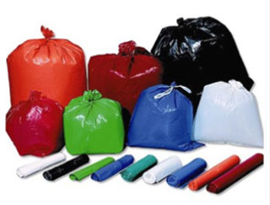
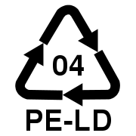

POLYETHYLENE TEREPHTHALATE
Known as PET, it is a plastic very common in bottles and textiles. Chemically, the PET is a polymer which is obtained from the polycondensation reaction between the terephthalate acid and the ethylene glycol. It is part of the group of synthetic materials named as polyesters. It is a thermoplastic polymer, which a high grade of crystallinity.
Characteristics:
- Good resistance against attrition and corrosion.
- Very high coefficient of glide.
- Good thermal and chemical resistance.
- Very good barrier against CO₂, acceptable against O₂ and humidity.
- Compatible with other barrier materials which improve the quality of the barrier of the containers, making them able to being used into specific markets.
- Recyclable, though it tends to decrease its viscosity with the thermal treatments.
- Approved for being used into products which are in contact with aliments.

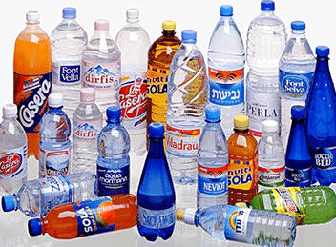
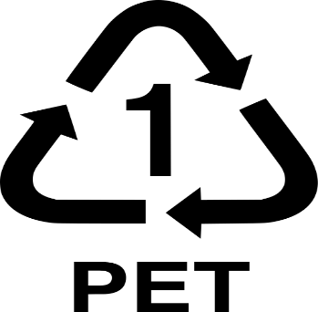

6.1.1 Materials and reagents

Alongside the session we used the following materials:

Mass spectrometer:
The mass spectrometer is a device which makes us able to analyse accurately the composition of different chemical elements and atomic isotopes, separating the atomic cores according to its relation between mass and charge (m/z). It can be used to identify the different chemical elements of a compound, or to determine the isotopic content of the different elements of a compound.
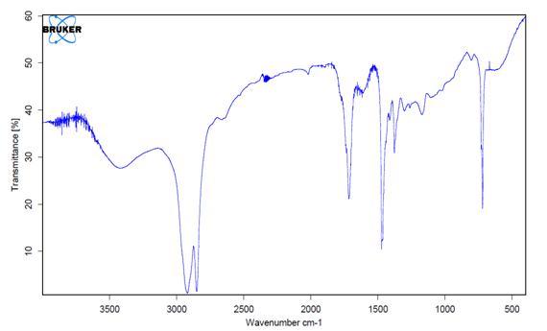
The mass spectrometer measures reasons mass/charge of the ions, heating them with a material beam of the compound we want to analyse until vaporize and ionize its different atoms. The ions beam produces a specific pattern in the detector, which allows us to analyse the compound.
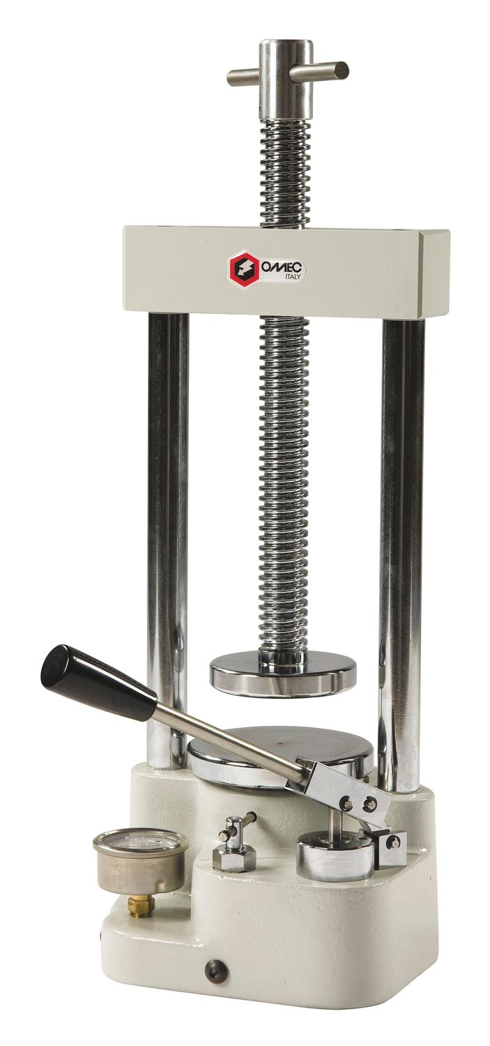
Spectrometry of our Polyethylene (PE)

Laboratory press:
It is a mechanism conformed by communicative vessels driven by pistons of different areas which, thanks to a little force applied into the minor area’s piston, allows us to obtain a bigger force in the piston which are is bigger. We used it for the preparation of the plastic samples that we would use in the following analysis, making them thick sheets that would be introduced in the mass spectrometer (it was not only used for the film paper sample, since its thickness was already appropriate).

6.1.3 Analysis of the obtained results

To make the analysis of the samples we used the mass spectrometer, so then we could obtained the different spectres to determine which plastic was in each case. Thanks to this, we obtained the following spectres, from left to right: spectra of our polyethylene, of the industrial polyethylene, of the polypropylene and comparisons between them.

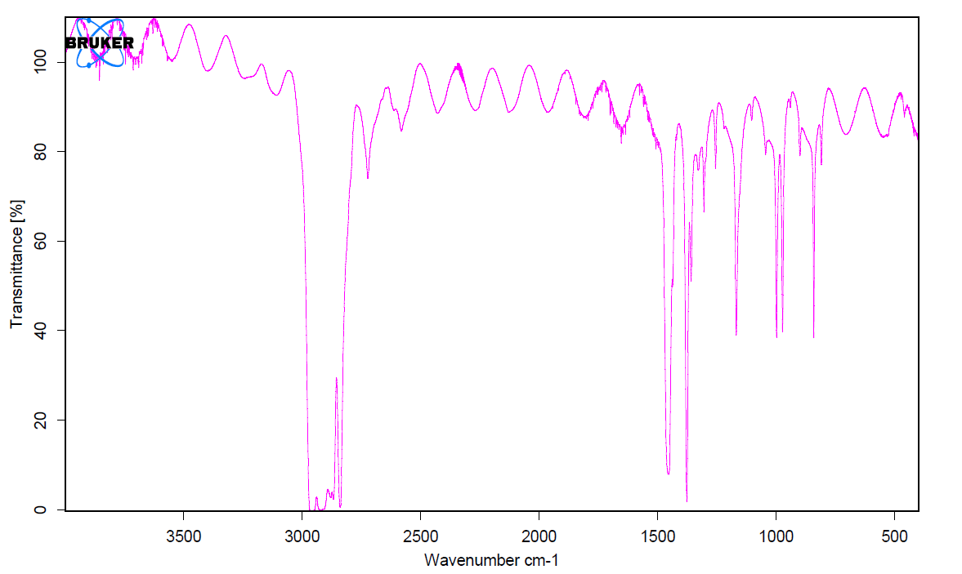
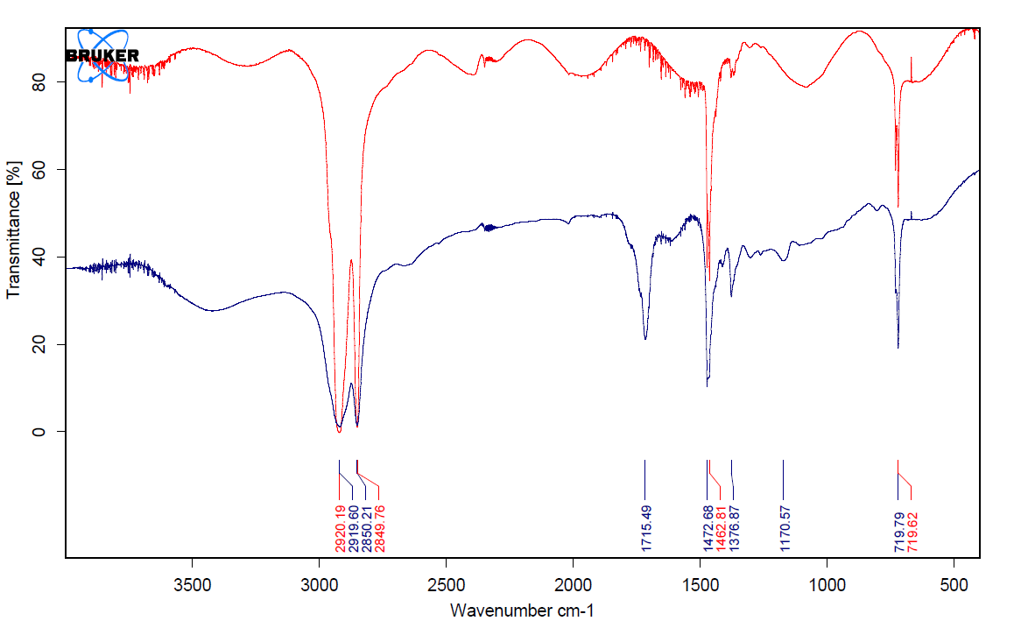
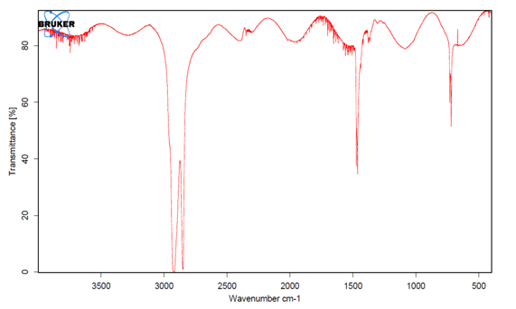
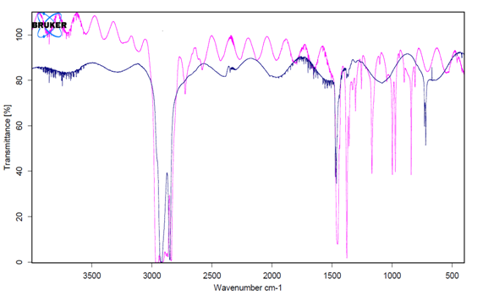
Own made PE (blue), commercial PE (red) Commercial PP (purple), PET (blue)

6.1.4 Conclusions

Firstly, after analyse the spectres of our polyethylene samples (the one that we made and the one from the film paper), we could see that the main difference between both of them was that our polymer had several contaminations, highlighting the presence of stripes characteristics of the water. This was caused because the sample had not been properly dried, so, for this reason, its spectra was altered.
On the other hand, after making an analysis of the polypropylene sample, we were able to appreciate its characteristic stripes. After this, we compared its spectra with the PET sample’s one, with the objective of appreciating their main differences.
Finally, we made the same experience with our PET sample, reaching as conclusion that, how we thought, it was the polyethylene terephthalate, something that we certificated after seeing, for comparison, a spectrometry clearly characteristic of this polymer in our sample.

Separation Methods of polymers by physical methods

6.2.1 Identification of variables
The variables to be studied are:
- Elasticity.
- Heat (it softens or not)
- Ignition (if it burns, ashes color, smell ...)
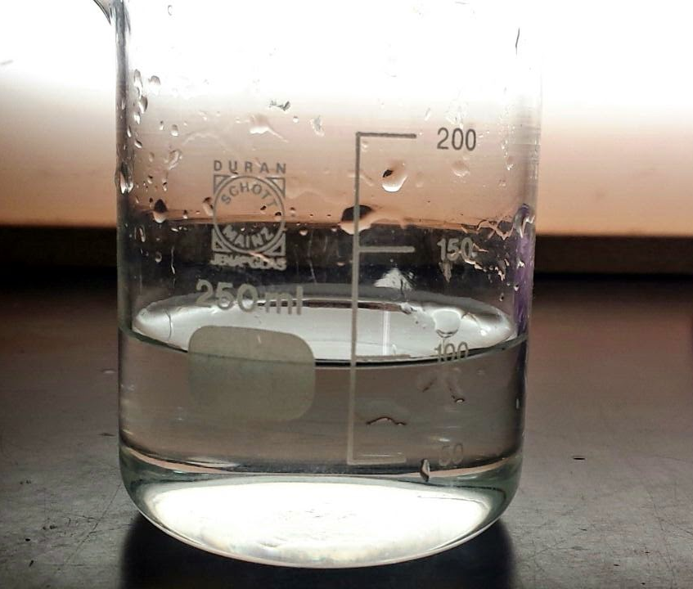
- Buoyancy.
- Solubility in acetone.

6.2.2 Experimental method

As experimental methods we will use the following:
- Elasticity.
- Buoyancy in water.
- Dissolution in acetone.
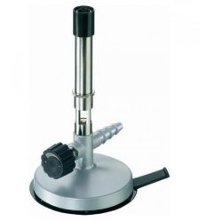
- Behavior against high temperatures.

6.2.3 Material

The material we used to perform the analysis was:
- Laboratory burner.
- Precipitate glass with water.
- Precipitate cup with acetone.
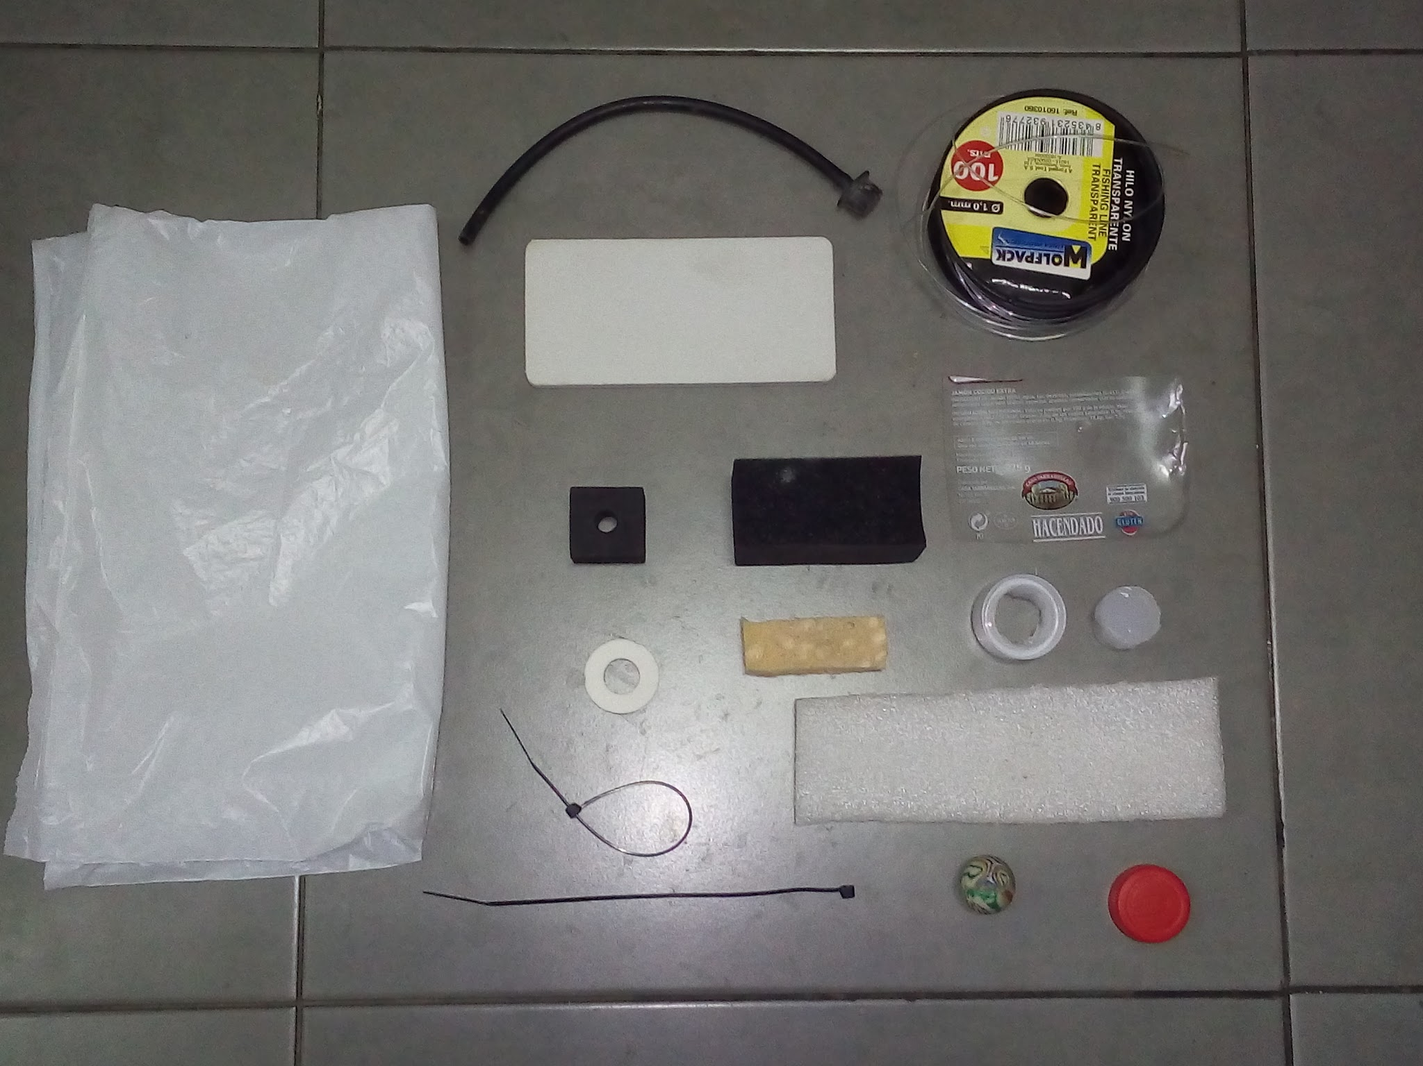
- Polymer Library.
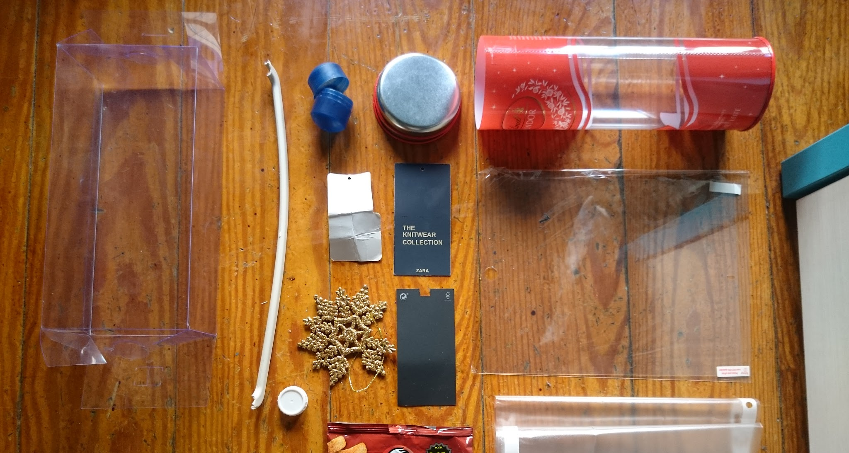

6.2.4 Procedures

When classifying plastics we follow this procedure:
1. Through different torsion and tensile stresses we determine if the sample could be an elastomer. If it is elastic, we check its buoyancy in water, being able to float (belonging then to the family of gums), or not, in which case we check by a flame if it burns, which can then be a polystyrene rubber or silicone, the latter in case of that doesn't burn.
2. If it is not elastic, by means of heat we check if it softens or not. If it does not, it would be a thermoset resin, however, if it softens, it would be a thermoplastic.
3. Next we check the buoyancy in water of the thermoplastic. If it floats, it would be either polyethylene (PE) or polypropylene (PP).
4. If it does not float, it is put in contact with a flame. If it does not burn it would be Teflon (PTFE), if the flame is extinguished, it would be polyvinyl chloride (PVC), and if it burns, it is necessary to check its solubility in acetone, it can be polystyrene (PS) Or polyethylene terephthalate (PET), polyamide or polycarbonate (PC) in the absence of solubility.
On the other hand, once this classification is made we rely on more specific properties of each plastic (such as the ash color, flame or smoke, smell that burns off ...) so that the analysis is more correct and accurate .
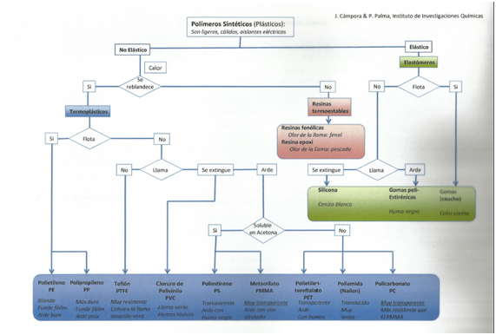
6.2.5 Job development

The classification of the polymers through physical properties is done as follows. We went to the laboratory, and once there we got the materials mentioned in the previous point and the plastics that we found more original. We made a first classification "by eye" of the plastics of which our polymer library was composed. We differentiate plastics from non-plastics, those materials that were composed of several types of polymers or those that had too much paint coating. Once the necessary ones have been selected, we use the materials like the lighter or water to perform the tests. For the post-test classification we used the table that was provided to us in CSIC, which is the one shown in the photograph. Depending on the behavior of the plastic before the various physical tests, we could find out almost exactly what type of plastic it was.
We made a first classification based on its elasticity and from here we elaborate three groups of plastics: the elastic, non-elastic and the intermediates.
They were gummings, gloves, silicone, etc.
Then we evaluate its buoyancy in a container with water.
And later whether or not they burned and what color was the smoke and the flame that they gave off.
With this data we prepared a table and a list with the name and qualities of each of the plastics, with the highest possible accuracy and following the table provided. We were also told how we could continue with the classification of polymers in our homes: seeing their origin and composition, etc. and all using the support table, which was very useful throughout the process.

6.2.6 Conclusions
In summary with the help of the table that we were given, we were able to recognize the different plastics of which everyday objects were composed. In addition we recognize it using easy means like water or fire that we can have at home.

7. PERSONAL VALUATION

From my point of view, the project is interesting because it helps to young people in the professionalism and personals field. We think the topic of the project can be of interest for somebody. Also, we believe that is useful, because the plastics are around us constantly, and we think that we have to inform us about them because they are complicated.

What’s more, we think that the programming has been correct, because the syllabus was distributing in form egalitarian. But, on the other hand, we would have liked do more practises by ourselves.

