DIFFERENCES BETWEEN PURE SUBSTANCES AND MIXTURES.

- Brainstorming
- What does pure substances mean? Give examples.
- What does mixtures mean? Give examples.
- Which states of matter have pure substance or mixture?
- Do you think all mixtures have to have visible substances?

- Learning outcomes
- How to differentiate between elements and compounds
- How to differentiate between homogeneus and heterogeneous mixtures
- How to differentiate between pure substance and mixtures

- Content language
Pure substance separate fixed proportions
Mixture properties change
Single element different form formed
Compound exothermic higher, lower
Energy homogeneus combinated
Melts heterogeneous boils
Temperature particle

- Model with scaffolding language

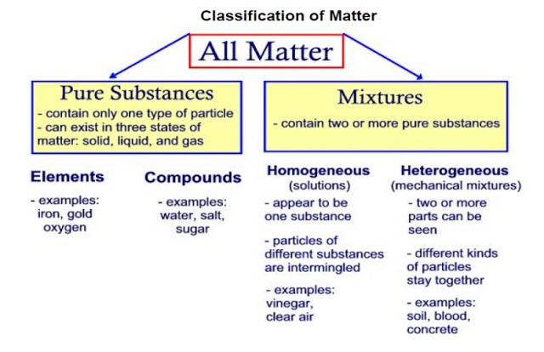
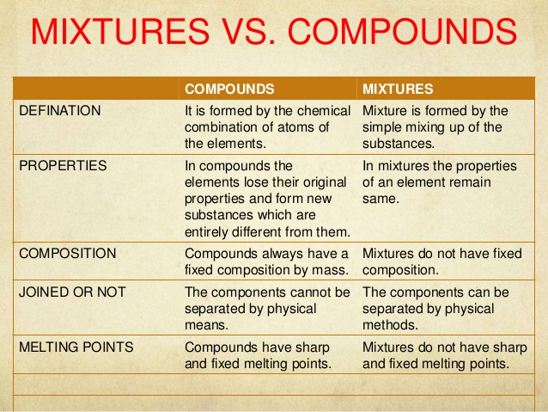

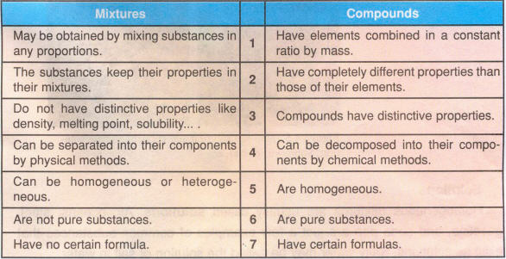

- Task for learners
Pure Substances |  | Mixtures
Elements | Compounds | Homogeneus | Heterogeneus

- Task support
You can take information from website in order to fill the table
www.majordifferences.com
https://www.chem.purdue.edu/gchelp/atoms/elements.html
http://www.ivyroses.com/Chemistry/GCSE/Elements-Mixtures-Compounds.php
https://www.reference.com/science/difference-between-mixture-compound-ac5cc16507bb8558

- Content language for learners´tasks
Go to point 3

- Scafolding language
Go to point 4

- Assessment criteria
You have to do a presentation about the difference between pure substances and mixtures.
Be sure you use all content and scaffolding language.
Prepare your presentation step by step.

