TETRIS
STUDENT A STUDENT B
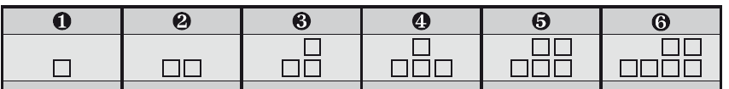
CAN | SHOULD | MUST | HAVE TO | DON’T HAVE TO | MUSTN’T
She won ‘the voice’ | I want to lose weight. | It’s raining. | My uncle is a pilot. | There is a lot of food in the fridge | You are at a hospital.
He plays in the NBA. | I failed my English exam. | I’m going to take an exam next week. | It is a formal  party | It’s Sunday. | You’re taking an exam right now.
She has lived in England for 3 years. | He has a headache. | The baby is sleeping. | You are driving and the traffic lights are red. | My granny has just fed the dog. | You are under 18 years old.
She has studied Arts. | She can’t sleep at night. | Some guests are coming home tonight. | He is a doctor | I’m on holidays. | You are in a museum.

