[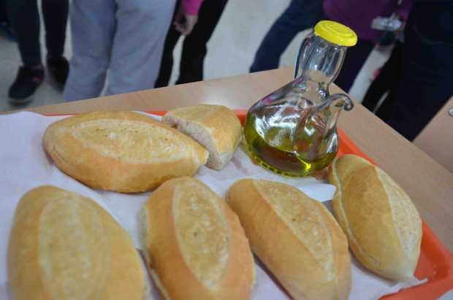](http://www.google.es/url?sa=i&rct=j&q=&esrc=s&source=images&cd=&cad=rja&uact=8&ved=0ahUKEwjK2eSunf_SAhUCWhQKHbTBAlsQjRwIBw&url=http%3A%2F%2Fwww.guadalmalaga.org%2Fdesayuno-andaluz-en-conmemoracion-al-dia-de-andalucia-en-los-centros-educativos%2F&psig=AFQjCNH6D4wAOkD-yPGZ-MhpPr1WkPoYSw&ust=1490997685458345)