UNIT 1 LIVING BEINGS: CELLS AND FUNCTIONS N.S. – 6

ACTIVITY 1. COMPARISON AND CONTRAST
- You have to comparate prokaryotic cell and a eukaryotic cells signing their similarities and differences. Complete this escheme.

ACTIVITY 2. TABLE
- Complete the table about unicelular and multicelular living beings.

LIVING BEINGS | ARE MADE UP OF… | IF THEY LIVE TOGETHER… | FOR EXAMPLE…
UNICELLULAR
MULTICELLULAR

ACTIVITY 3. ALONE NOT, WITH FRIENDS YES.

A) Multicellular living beings can live in groups that work together to perform a specific activity. Complete these estatements with these words:

Tissues | Multicellular living beings | Organs

- The tissues are a group of…
- The organs are a group of…
- The systems are a group of…

B) Cut and fix the images and put them in the correct order.
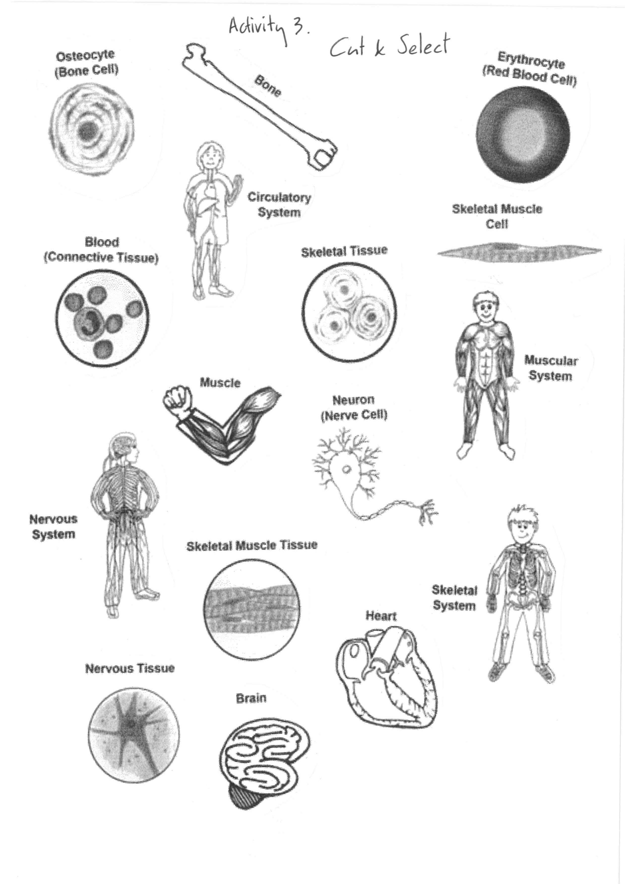

Cell | Tissue | Organ | System
ACTIVITY 4. AMAZING SIZE!!
- Look and comment these comparisons about size. Don´t you think that they´re really amazing?
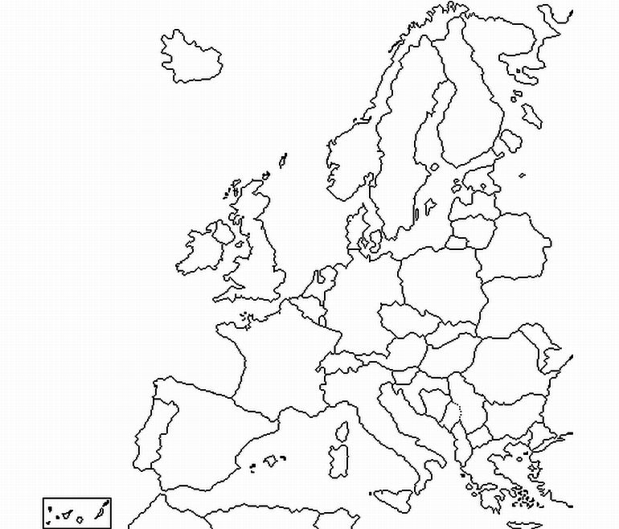
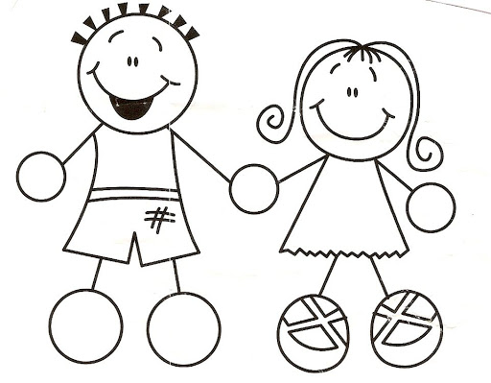

If you were as big as
Europe…

(10 million square kilometers)
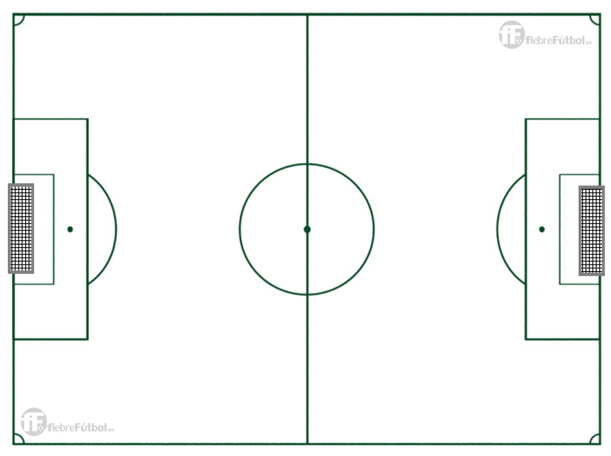
A unicelular fungus would be
as big as a football field

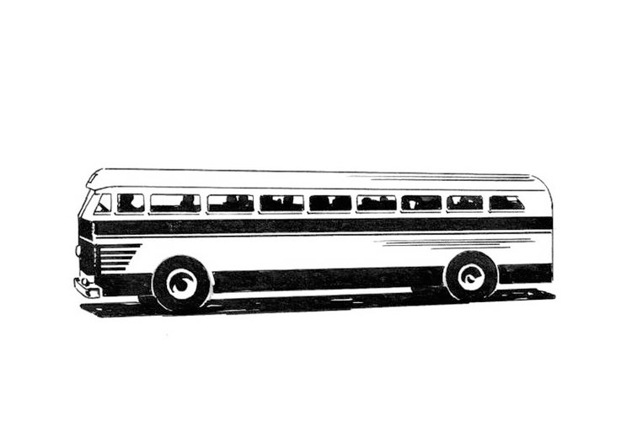
(10.800 square meters)

Bacteria would be as a bus.

(12 meters)

A virus would be like a football ball!!

(70 centimeters)

ACTIVITY 5. UNDER THE SEA
- Classify these statements about the protoctista kingdom under the sea.

Plankton
Green Algae

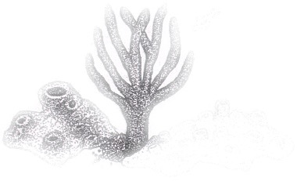

The Protoctista Kingdom under the sea:
- Acuatic animals feed on them.
- Humans, for example feed on them.
- They put oxygen.
- They remove carbón dioxide
- Protozoa
- Algae
- It´s a beneficial protozoa.

ACTIVITY 6. SOUP OF LETTERS
- Find five words related with benefits of Fungi Kingdom.

A L M G Y A S Y K H F
L N Z P R T G E G U W
C F T P S H I A L M H
O Q V I K M R S T U D
H F S P B J T T Y S L
O Z E O K I R W O D I
L X F B N P O M I R C
A P T V J D Y T A H X
G S B T M E D I C I N E
P O H K C I H F S C C G

ACTIVITY 7. THE ALPHABET GAME, PASS THE WORD
- You have to think a word that the definition referer. That Word have to begin by the indicated letter.

- With A. They can be multicelular os unicelular living being. They are autotrophic and normally live in water.
- With B. They belong Monera Kingdom. It´s unicelular living being and they haven´t got a nucleus. A lot of them are in antibiotics.
- With C. The smallest part of a living baing that complete the three vital functions.
- With D. Synonymous of illness, it could be caused by bacteria, fungi or virus.
- With E. Kind of cell, its genetic material is enclosed inside a nucleus.
- With F. Name of kingdom that mould, mushroom and yeast belong.
- With G. It´s a very important part of a cell. It can be in the cytoplasm or inside a nucleus.
- With H. Product made with remains of dead beings by the decomposers like the fungi or bacteria.
- With I. It´s one of the three vital functions.
- With J. Acuatic animal that belongs to cnidarians. It has various tissues with specialised cells.
- Contains K. Types of cells about structure.
- With L. They are a partnership of heterotrophic fungi and algae.
- With M. They can be poisonous or edible. They belong to fungi kingdom.
- With N. Part of a eukaryotic cell. It has got genetic material.
- With O. Part of a cell. They made up of tissues. They do very spesialised tasks. They sometimes form systems.
- With P. The main function of autotrophic nutrition.
- Contains Q. Way that bacteria can reproduce themselves. Adeverb.
- With R. One of the three vital functions.
- With S. Required element for the cells use autotrophic nutrition.
- With T. Group of cells that work together to perform a specific activity.
- With U. Someones live together in colonies, but they go on being independent beings.
- With V. Nutrition, interaction and reproduction are…
- With W. Place where we normally can find algae.
- Contains X. Kelp forest emit a lot of i tinto Earth´s atmosphere and oceans.
- With Y. Type of fungi that is used to make bread and alcoholic dinks or wine.
- Contains Z. Unicellular living being, it has a nucleus and is heterotrophic. Someones can cause serious diseases.

ACTIVITY 8. CROSSWORD
- Complete this crossword. 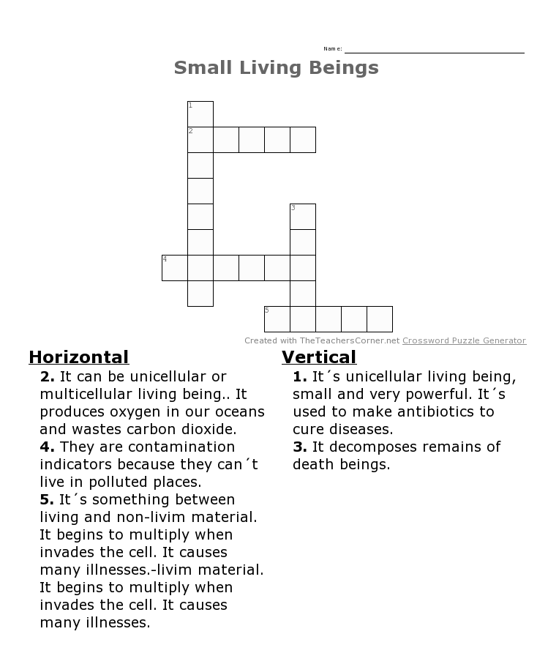

ACTIVITY 9. THE GAME OF THE TRUTH
- Sing ¨T¨ if the statement is true anf ¨F¨ if it´s false

- All cells have membrane, cytoplasm and genetic material.
- Cells can reproduce themselves making a copy of their genetic material and dividing the cytoplasm into two halves.
- Cells that use autotrophic nutrition make their own nutrients by photosyntesis.
- Most of cells don´t need to respire.
- Cells reléase waste material to the exterior throught the cell membrane.
- Cells are static beings, they don´t react.
- All cells use heterotrophic nutrition, depend on other living beings.

