“Sk8er boy” by Avril Lavigne
He was a 1. _____________
She was a girl
Can I make it any more obvious
He 2. __________ a punk
She did ballet
What more can I say
He 3._____________ her
She'd never tell secretly she 3. _____________ him as well
But all of her friends
Stuck up their nose
They had a problem with his baggy clothes
He was a skater boy
She 4. _________ see you later boy
He wasn't good enough for her
She 5. _____________ a pretty face
But her head 2. __________ up in space
She needed to come back down to earth
6. _________ years from now
She sits at home
Feeding the baby she's all alone
She turns on TV
Guess who she 7. _____________
Skater boy rockin' up MTV
She calls up her friends
They already know
And they've all got
Tickets to see his show
She tags along
Stands in the crowd
8. __________ up at the man that she turned down
He was a skater boy
She 4. _________ see you later boy
He wasn't good enough for her
Now he's a super star
Slamming on his guitar
Does your pretty face see what he's worth?
He 2. ________ a skater boy
She 4. _________ see you later boy
He wasn't good enough for her
Now he's a super star
Slamming on his guitar
Does your pretty face see what he's worth?
Sorry girl but you missed out
Well tough luck that 1. __________'s mine now
We are more than just good friends
This is how the story ends
Too bad that you couldn't see,
See the man that 1. ____________ could be
There is more that meets the eye
I see the soul that is inside
He's just a 1. _______________
And I'm just a girl
Can I make it any more obvious
We are in love
Haven't you heard
How we rock each other’s world
I'm with the skater 1.__________
I 4. ___________ see you later 1. _____________
I'll be back stage after the show
I'll be at the studio
Singing the song we 9. _____________
About a girl you used to know
I'm with the skater 1. __________
I 4. ___________ see you later 1. ______________
I'll be back stage after the show
I'll be at the studio
Singing the song we 9. _____________________
About a girl you used to know

BEFORE LISTENING
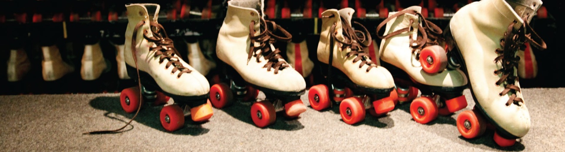
- Do you like skating? Say different activities you like practicing in your free time.

- “Punk” is a word with different meanings. According to one of these meanings, a punk is a person who doesn’t behave well. This word can be applied to a person who bullies other people, for example. In the song we are about to listen, the male protagonist was a punk, and the female protagonist did ballet. Imagine the physical description of these people and tell the people in the class. You can check this web page to find vocabulary which can help you:
https://www.youtube.com/watch?v=h_f-cYlwVqQ

WHILE LISTENING
- Listen to the song and fill in the gaps with the missing words.

AFTER LISTENING
- The words and expressions given can be found in the text. Can you guess their meanings? Relate numbers and letters to show the words’ definitions:

- Baggy | (1) You find it difficult to concentrate.
- Head up in space | (2) Be realistic.
- Come back down to earth | (3) Don’t consider the things you can see are the only valid source of information.
d. Turn down | (4) Reject.
- There’s more than meets the eye | (5) Clear, observable.
- Obvious | (6) Hanging loosely.

- In the song, two verbal tenses are used most of the time. Which are these tenses? When do we use them?

- Grammar practice: do the exercises you can find in these web pages. It’s a good way of revising simple past and simple present:

http://www.myenglishpages.com/site_php_files/grammar-exercise-simple-past.php
http://www.englisch-hilfen.de/en/exercises/tenses/simple_present_mix.htm
When you finish, click the button to check if you did them well.

- HOMEWORK
Write a story using simple past tense about two people who fell in love. Don’t forget to include in your story basic information such as:
Who are they? When did they meet? Where? What’s the first thing they thought about each other? Why did they like each other?

ANSWERS
Exercise 3:
- Boy
- Was
- Wanted
- Said
- Had
- Five
- Sees
- Looks
- Wrote
Exercise 4:
A6 B1 C2 D4 E3 F5

Exercise 5:
Simple past and simple present are the 2 verbal tenses used most of the time.
Simple past uses:
http://www.englishpage.com/verbpage/simplepast.html
Simple present uses:
http://www.englishpage.com/verbpage/simplepresent.html

LEVEL: second year ESO.
TOPIC: love and relationships.
SKILLS: listening, reading, speaking and writing.
GRAMMAR: revision of simple past and simple present.
VOCABULARY: describing people physically and psychologically. Free time activities.
TIMING: 1 session (+homework).
PROCEDURE:
1 and 2. Before listening to the song, the students will have to answer exercises 1 and 2 orally. There’s a video they’ll watch and this will help them to revise vocabulary used when we have to describe a person in English. The teacher will elicit some more vocabulary from them and will correct any pronunciation mistake present in their productions.
3. The teacher will introduce the song and the author to the students giving some important information about her. Then he/she will show the lyrics on the screen and the students will have to listen to the song and complete it with the missing words. They will listen to the song 2 times. After listening, the students can check their answers with their partners and then they will present their answers together on a piece of paper. Then, the papers with the answers will be given at random to the students and the students will verify if their answers are right checking them with the correct answers that will be written on the board by the teacher. Teacher and students will listen to the song for the last time; in this way the students can check the missing words and their pronunciation and they can sing the song if they want to do so.
4. The students will have to match words and expressions taken from the song with the definitions given. If necessary, the teacher will help the students to deduce and understand the different words and expressions.

5. The students will orally answer the questions given. The teacher will help the students to find a correct answer if they have problems to do so and will briefly explain the uses of these two tenses. He/she can show the information found in these 2 web pages in the digital blackboard as an aid to do so:
Simple past uses:
http://www.englishpage.com/verbpage/simplepast.html
Simple present uses:
http://www.englishpage.com/verbpage/simplepresent.html

6. Using the digital blackboard, the teacher will show the students the grammar exercises they will do in class. The teacher will ask for some voluntary students to come to the digital blackboard to do the exercises. The rest of the class will be paying attention and the exercises will be corrected online.
7. The teacher will explain the homework students will have to prepare for next class: a composition to tell the story of two people who fell in love. This homework will be given to the teacher who will correct each composition.

