NAME..........................................................SURNAME...................................................
DATE...........................................................................................Class 4º ..……. Nº........
The weather is………………………………………………….Today I feel ……………………………………..
UNIT HELLO THERE!
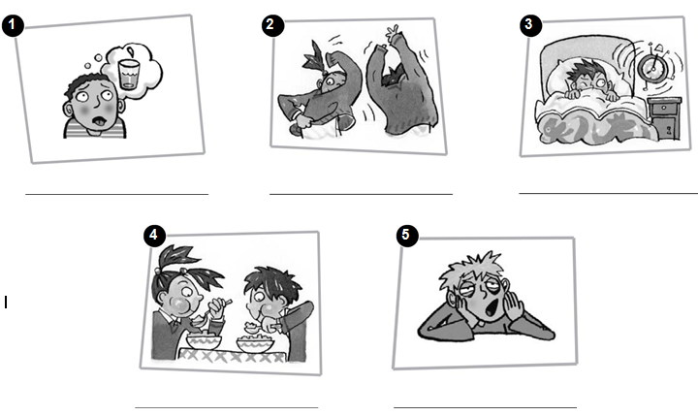
1. Look at the pictures and write the words.

2. Read and match. Write the letters. There is one extra option.
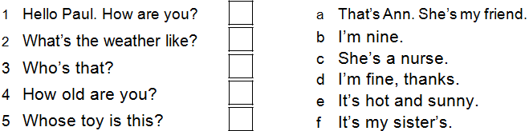

3. Listen to your teacher and write the daily routines:

4. Read and answer the questions in complete sentences.
My cousin Susan’s a dentist. She lives in a flat. She always gets up at seven o’clock and goes to work. She has lunch at one o’clock. She sometimes works at the weekend, but she doesn’t like it. She likes taking photos and watching TV in the evenings. She loves her job.

- What is Susan’s job?______________________________

- Where does Susan live? ____________________________

- What time does Susan have lunch?_____________________

- Does Susan like working at the weekend?_________________

- What does Susan like to do in the evenings?________________

