NAME..........................................................SURNAME...................................................
DATE...........................................................................................Class 4º ..……. Nº........
The weather is………………………………………………….Today I feel ……………………………………..
Unit 1
Listening
1. Listen and draw the lines. Colour. (6 marks)
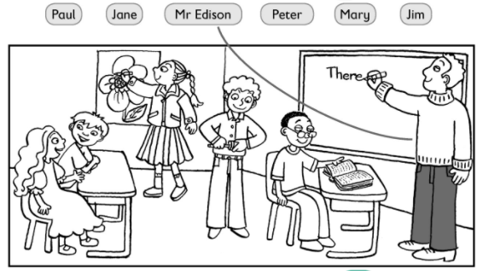
2.Read and circle the correct answer. (4 marks)
a) Mary is the girl who´s/ who are doing her homework.
b) The girls who´ve got/who´s got brown hair are my friends.
c) The boy who are/who´s sad is my brother.
d) Peter and John who´s/who´ve got glasses are twins.

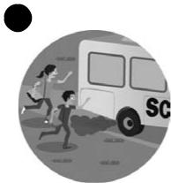
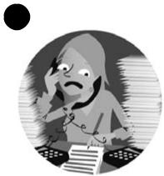
3. Write the words. Match them to the pictures. (4 marks)

onribg__________
cukqi__________

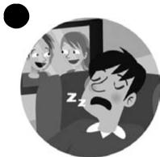
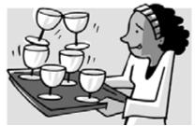
usby_____________
fealcru__________

4. Read and circle yes or no. (5 marks)
The Star family are at school because they want to see Stella and Simon. Stella’s singing and Simon is playing the guitar. Mrs Star is talking to Simon’s geography teacher and Mr Star is helping with the music. He thinks music is exciting.

1 | The Star family are at the school. | yes | no
2 | Simon is singing. | yes | no
3 | Mrs Star is talking to the music teacher. | yes | no
4 | Mr Star is playing the piano. | yes | no
5 | Mr Star thinks music is exciting. | yes | no

5.Write your opinion. (6 marks)
I like going to school. I think ______________ is difficult but I enjoy it. My favourite subjects
are ____________________ and ____________________.
I think Art is fun and Sport is_______________________.
My favourite sport is ______________________ .
I don´t like ____________________.
I think the best time of the day is lunchtime!

