NAME..........................................................SURNAME...................................................
DATE...........................................................................................Class 4º ..……. Nº........
The weather is………………………………………………….Today I feel ……………………………………..
Unit 2
Listening
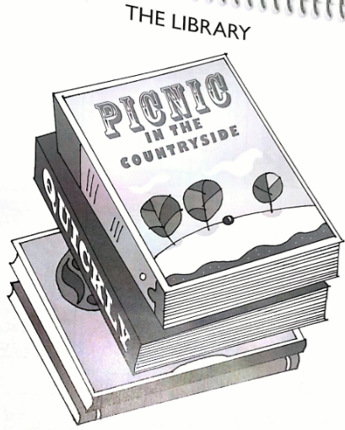
- Listen and look and write. There is one example. (5 marks)

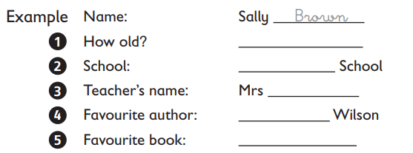
- Look at the pictures. What did Paul do last week? Listen, look and match. There is one example. There is one extra day. (5 marks)
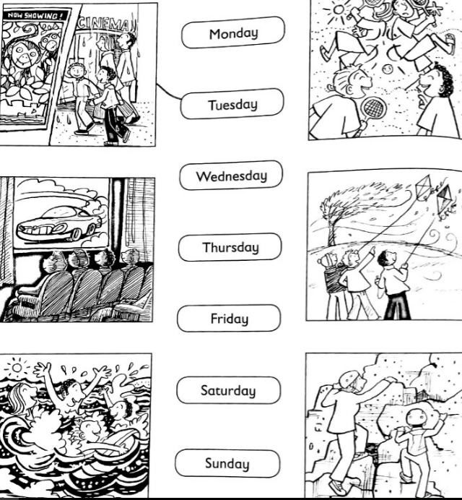

- Write the sentences in order. (5 marks)
learn - swim. - We - want to - to

She - to - wants to - dance - learn

doesn´t - want - to - He - learn - to - sail

I - learn to – want - run -well - to

don´t - want - learn - skip - to - to - They

- Look at the pictures and complete the sentences with an adverb. (5 marks)
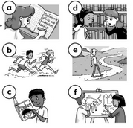
a. She´s writing carefully
b. They´re running _________________
c. He´s reading _____________________
d. They´re speaking _________________
e. She´s walking ____________________
f. They´re drawing __________________

- Look at the pictures and write the words. (10 Marks)
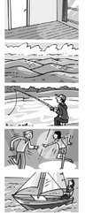
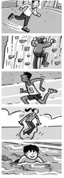

- Write the words. (5 marks)
- What do we call people who teach? _______________________
- What do we call people who dance? _______________________
- What do we call people who sing? _______________________
- A place where you can sail. _____________________________
- A place where you can skate. ___________________________

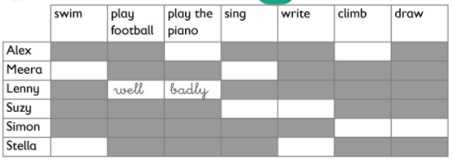
- Read and complete the table. (5 marks)
