NAME..........................................................SURNAME...................................................
DATE...........................................................................................Class 4º ..……. Nº........
The weather is………………………………………………….Today I feel ……………………………………..
Unit 3
Listening
1.Listen and write. There is one example.(5 marks)
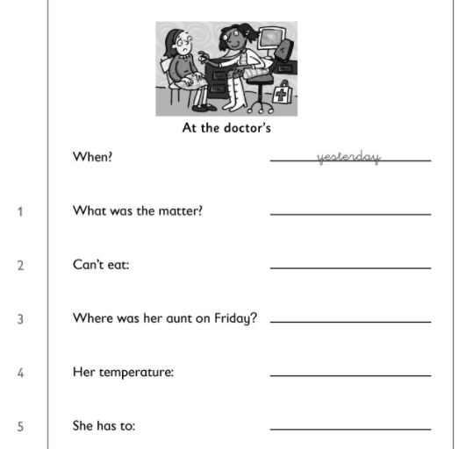
2. Listen and draw lines. What did Sandra´s friends do last week?
(5 marks)
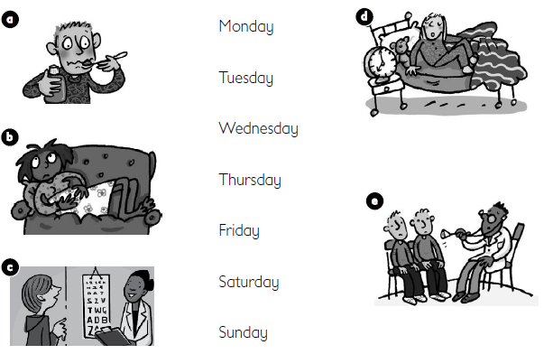

Reading and writing
3.Write the past form. (10 marks)
is | are | have | go | See
eat | drink | give | take | today

4. Look at the pictures and make sentences according to them. Use past simple (3 marks)
A. __________________________________________
B. __________________________________________
C. _________________________________________

5. Change into the negative form. (2 Marks)

Last night, I went to the hospital.

Yesterday, she drank a lot of milk.

6. Change into the interrogative form. (2 marks)
They went to Disney.

We ate a big burger.

7. Read and match. Write the letters . There is one extra option. (5 marks)
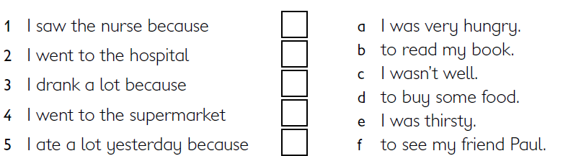
8. Look at the pictures and read the story. Write some words to complete the sentences about the story. You can use 1,2 or 3 words. (8 marks)
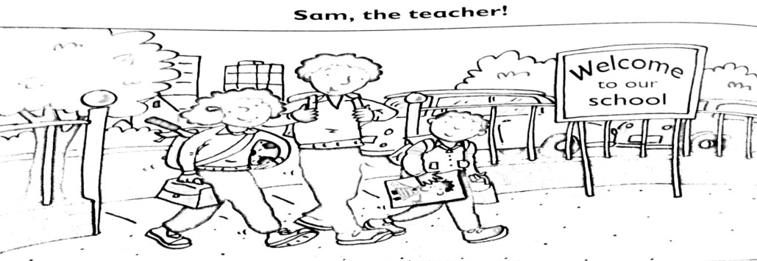
Sam lives in the countryside with his parents and his sister, Mary, and his brother, Paul. Sam is ten, Mary is eight and Paul is six. They live in the countryside but they go to school in the city. Sam is the one who likes Science, his sister is the one who likes Sport and his brother is the one who likes Art.

1. Sam´s family________________________ countryside.

2. The children go to school ________________________

3.Sam´s favourite subject is ________________________

4._____________________ is the one who like Sport.

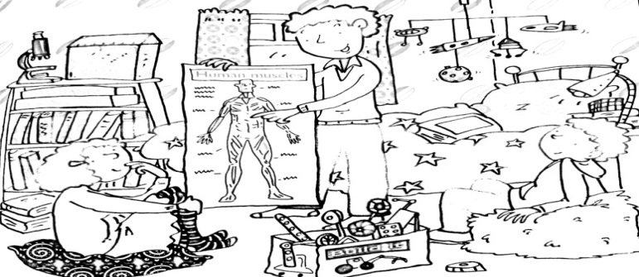

Last week, Sam had a class about the huma body. He listened carefully and when he went home he gave his younger brother and sister a class about the subject. The wanted to listen because it was very interesting. Sam said, “ We move because we have 600 muscles in our body. The muscles need oxygen. We use our lungs to take oxygen from the air into our body”.

5.Last week, Sam studied _____________________________ at school.

6. Sam gave his brother and sister a class when he went ______________________

7. Mary and Paul wanted to learn because it was very ________________________

8. We use our lungs because our muscles _______________________________

