NAME..........................................................SURNAME...................................................
DATE...........................................................................................Class 4º ..……. Nº........
The weather is………………………………………………….Today I feel ……………………………………..
Unit 4
Listening
1. Listen and tick the box. There is one example.(5 marks)
What was the matter with Jim? | 3.What does Jim like best?  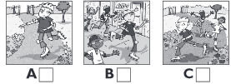
1.Which is the doctor? | 4. How old is Jim´s sister?  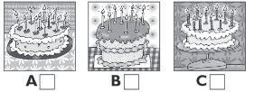
2.Where did Jim go on Friday?  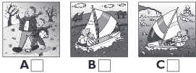 | 5.How many books did she have for her birthday?

2. Listen and write the ordinal numbers. (10 marks)

Reading and writing
3.Write the past form. (10 marks)
carry | play | stop | sail | snow
like | watch | kick | dance | live

4. Write the ordinal numbers. There is one example. (10 marks)
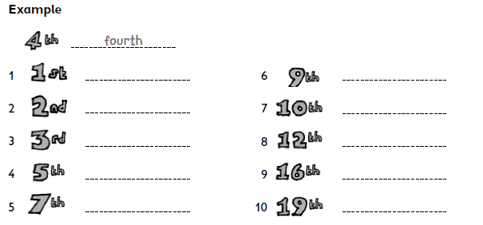
5. Complete the text. Use the past of the verb. (5 Marks)

On Saturday Katie was the Sandra´s house.

They …………………. (watch) a film on TV. The film was very funny and they ……..

…………..(laugh) a lot. They also ………………… (dance). They called their friend Mary

and they ………………. (play) in the garden for hours. They ………………(talk) all

afternoon. They had a fantastic time.

6. Change into negative or interrogative. (5 marks)
(?) Last year they danced to music.

(X) Last weekend we watched a film in his house.

(?) Last night I cooked a chicken.

(X) Yesterday afternoon he climbed the mountains.

(X) Yesterday she kicked the ball.

7. Read the story and answer the questions in complete sentences. (5 marks)

