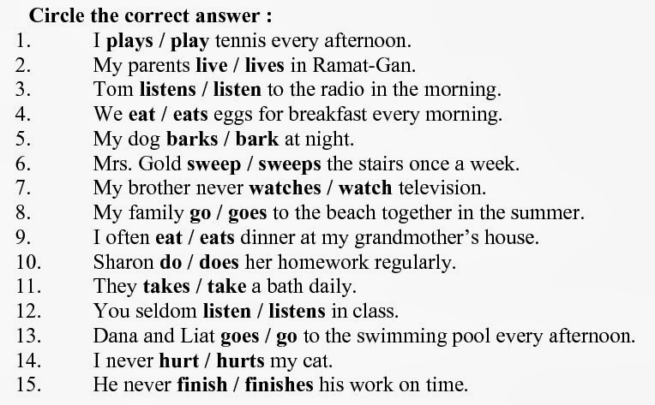

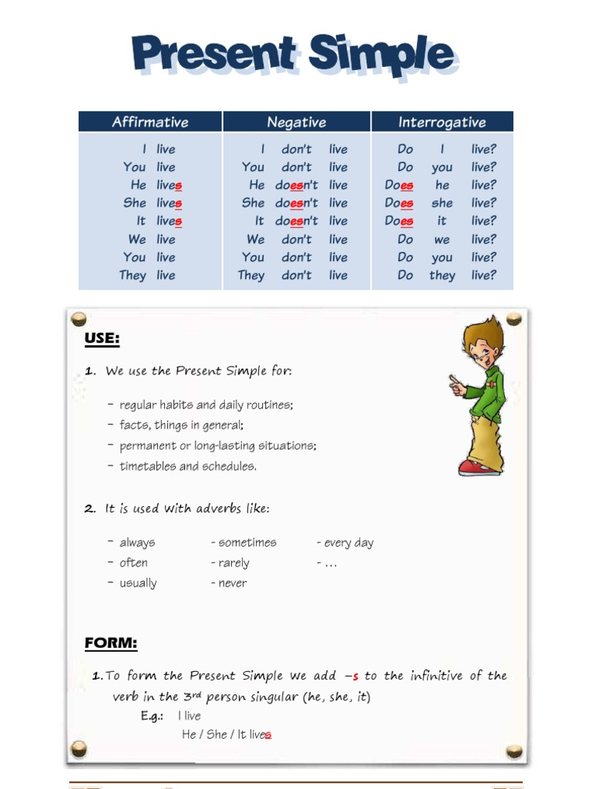

2. Write in affrimative (✓), negative(✗) or interrogative(**?**).

a. I / go / to school / every day (✓) _______________

____________________________________________

b. they / learn / German / at school (✗) ___________

____________________________________________

c. you / play / the guitar (?) ______________________

____________________________________________

d. Charlie / watch / TV / at the weekend (✓) ________

____________________________________________

e. we / play / rugby / at school (✗) _______________

____________________________________________

f. they / eat / meat (?) __________________________

____________________________________________

1.Complete with the correct form:

a. I _____________ (go) to school on Mondays. I _________________________ (not/go) to school at the weekend.

b. We ___________________ (not/play) rugby at school, but we ______________ (play) football.

c. __________ (Do/Does) he __________ (learn) German at school? Yes, _____ _________ .

d. __________ (Do/Does) you _________ (live) in Madrid? No, I __________.

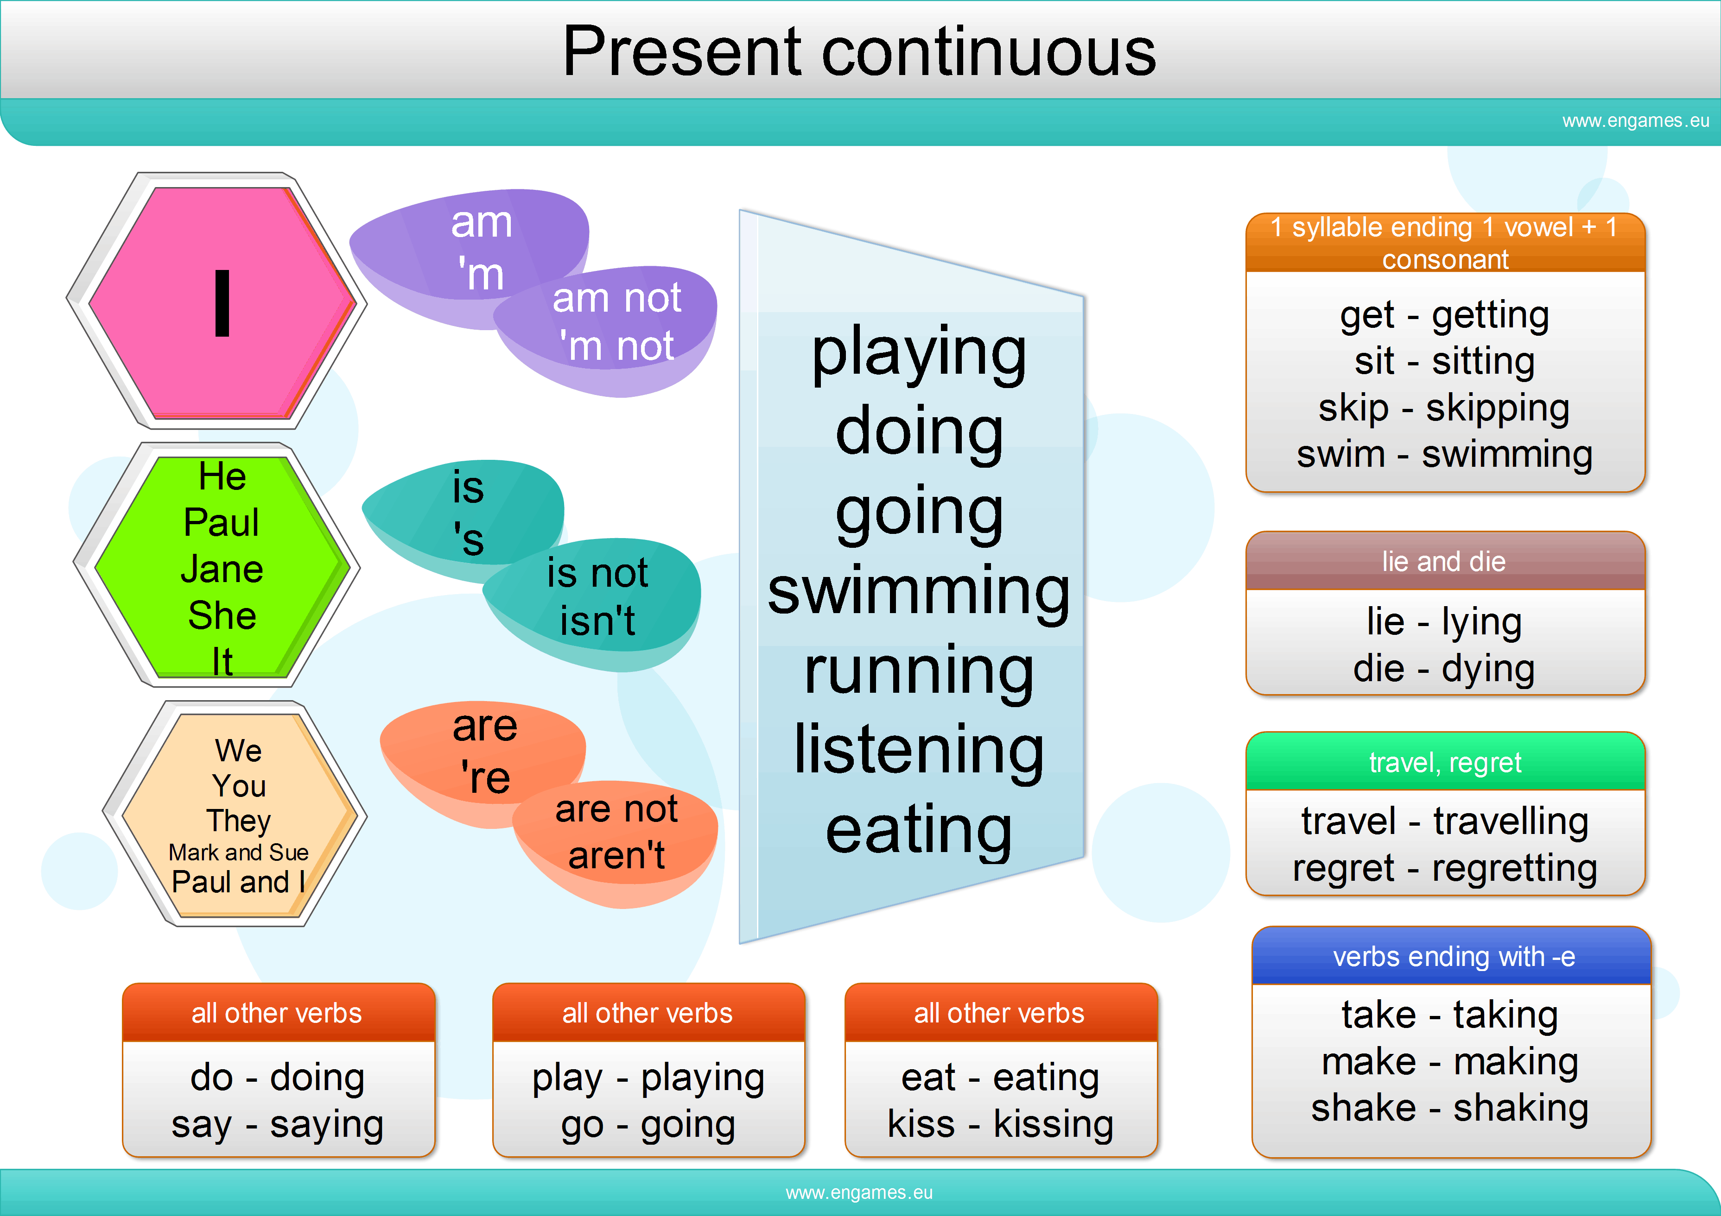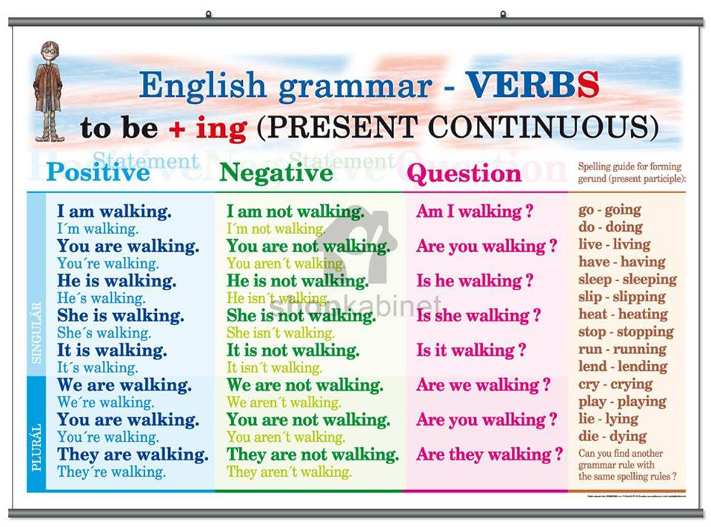

We use the **present continuous** whe talk at the moment:

I am working **right now.**

**At the moment,** They are playing football.

He is studing English **now.**

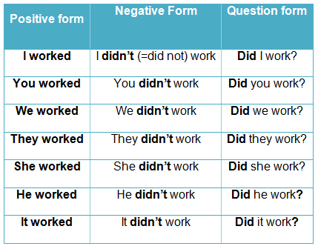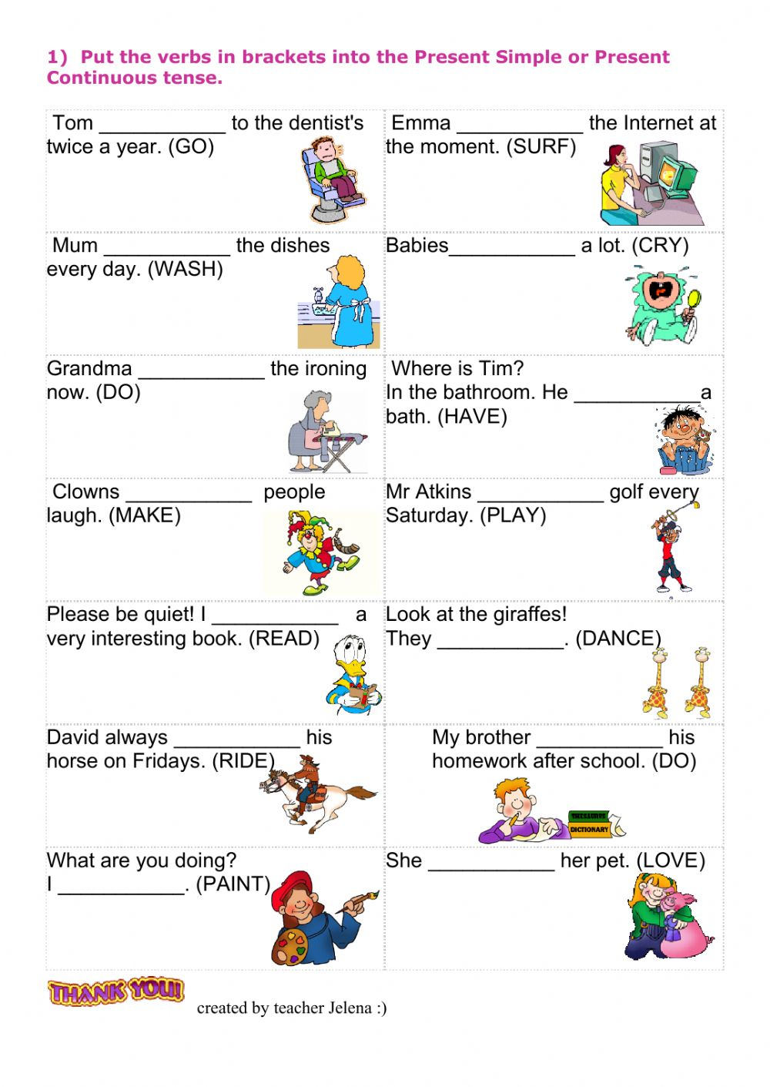

**PAST SIMPLE**

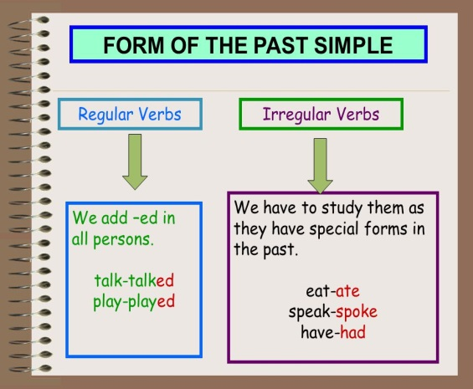

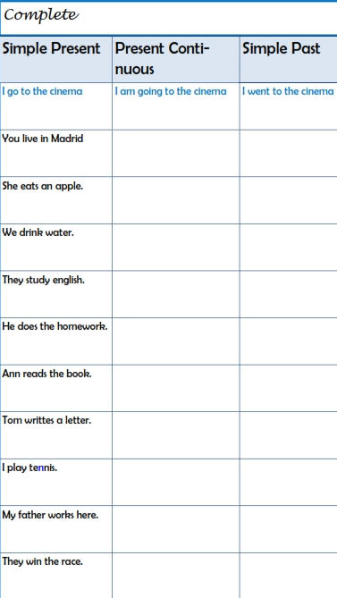

**Write in past simple (affirmative form):**

a. Today, I eat pizza. ______________________________________________

b. Sue go to the hospital. __________________________________________

c. He take some medicine. ________________________________________

**Change into the negative form.**

**a.** ____________________________________________________________

b. _____________________________________________________________

**c.** _____________________________________________________________

**Change into the interrogative form.**

**a.** _____________________________________________________________

b. _____________________________________________________________

**c.** _____________________________________________________________