NAME..........................................................SURNAME...................................................
DATE...........................................................................................Class 4º ..……. Nº........
- Look and write the words.
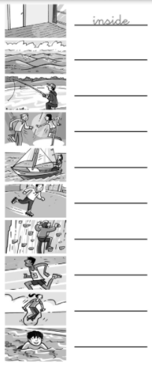

- What can I learn to do? What do you want to do? Review the grammar and answer the questions writing 5 sentences about you. Use the different verbs that you have studied.
- __________________________________________________
- __________________________________________________
- __________________________________________________
- __________________________________________________
- __________________________________________________

- Write the words.
- What do we call people who climb? _______________________
- What do we call people who dance? _______________________
- What do we call people who win? _______________________
- What do we call people who swim? _______________________
- What do we call people who skate? _______________________

- Read the song. Then, you circle the adverbs (quickly, quietly, carefully…).
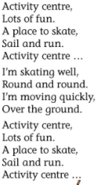
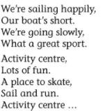

- Now write all adverbs here:____________________________
_________________________________________________
- Write the sentences in order.
learn - swim. - We - want to - to

She - to - wants to - dance - learn

doesn´t - want - to - He - learn - to - sail

I - learn to – want - run -well - to

