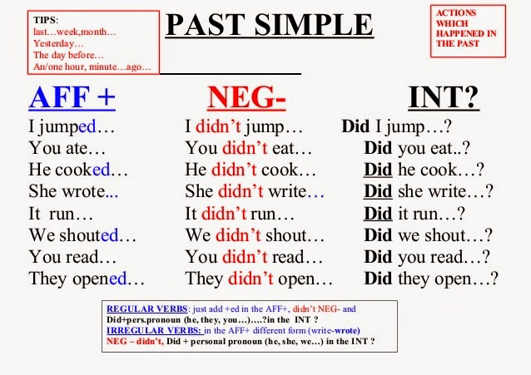

1. Write the following in verbs in affirmative, negative and interrogative past tense.
HAVE
AFFIRMATIVE + | NEGATIVE - | INTERROGATIVE ?
I __________________  YOU_______________  HE_________________  SHE________________  IT__________________  WE________________  YOU_______________  THEY_______________ | ________________________  ________________________  ________________________  ________________________  ________________________  ________________________  ________________________  ________________________ | ________________________  ________________________  ________________________  ________________________  ________________________  ________________________  ________________________  ________________________
GIVE
AFFIRMATIVE + | NEGATIVE - | INTERROGATIVE ?
I __________________  YOU_______________  HE_________________  SHE________________  IT__________________  WE________________  YOU_______________  THEY_______________ | ________________________  ________________________  ________________________  ________________________  ________________________  ________________________  ________________________  ________________________ | ________________________  ________________________  ________________________  ________________________  ________________________  ________________________  ________________________  ________________________

2. Look at the pictures and make sentences according to them. Use past simple (5 marks)
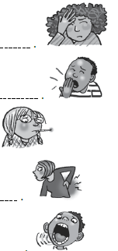
A. ____ _____________________________________

B. ___________________________________________

C. __________________________________________

D. ___________________________________________
E. ___________________________________________

3. Change into the negative form.
a. Last month, I ate pizza. _____________________________________________________
b. Sue went to the hospital. ___________________________________________________
c. He took some medicine. _____________________________________________________
4. Change into the interrogative form.
a. Last month, I ate pizza. _____________________________________________________
b. Sue went to the hospital. ___________________________________________________
c. He took some medicine. _____________________________________________________

5. Read, choose and write the correct verb.
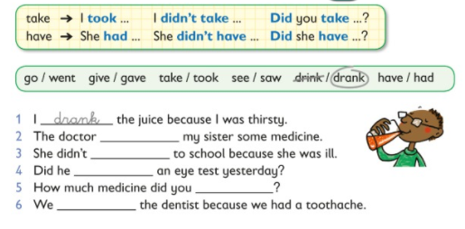
6. Answer the questions.
Did she go to the hospital?__________________________
________________________________________________

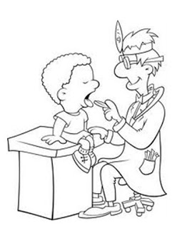
Did she eat ice cream?____________________________
________________________________________________

Did he see the doctor?_____________________________

